Capture Moments-Aws powered Photographer booking system

## Project Description:

At Capture Moments Photography, the growing client base has created challenges in managing bookings and connecting customers with the right photographers. The manual booking process was inefficient and prone to errors, causing scheduling conflicts and customer dissatisfaction.

To solve this, Capture Moments developed a cloud-based Photographer Booking Platform. Using Flask for backend development, AWS EC2 for hosting, and DynamoDB for managing data, the system allows clients to register, log in, and book photographers online. This cloud-based solution enhances the booking experience, providing seamless service for all clients while optimizing photographer scheduling and data management.

**Scenario 1: Efficient Booking System for Clients**

In the Capture Moments Booking Platform, AWS EC2 ensures a reliable infrastructure to manage multiple clients accessing the platform simultaneously. For example, a client can log in, navigate to the booking page, and easily submit a request for their preferred photographer. Flask handles backend operations, efficiently retrieving and processing user data in real-time. The cloud-based architecture allows the platform to handle a high volume of booking requests during peak wedding seasons, ensuring smooth operation without delays.

**Scenario 2: Centralized Booking Management**

When clients book photography sessions, the Capture Moments Booking System processes these requests through a streamlined workflow. For instance, a client books a wedding photographer, and Flask processes the request, storing all the booking details securely in DynamoDB. This centralized database approach ensures all booking information is maintained in a single source of truth, allowing administrative staff to track upcoming appointments, manage photographer schedules, and maintain complete records of client preferences and requirements.

**Scenario 3: Easy Access to Photography Services**

The Capture Moments Booking Platform provides clients with easy access to available photographers and packages. For example, a client logs in and views the list of available photographers specializing in their event type. They can quickly check availability for specific dates or book immediately. Flask manages real-time data fetching from DynamoDB, while EC2 hosting ensures the platform performs seamlessly even when multiple clients access it simultaneously during popular booking periods, offering a smooth and uninterrupted user experience.

AWS ARCHITECTURE

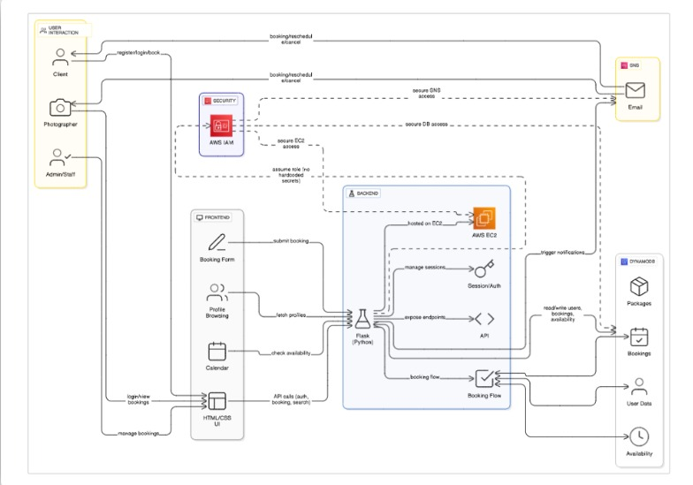

Entity Relationship (ER)Diagram:

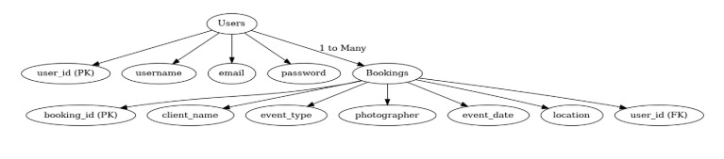

## Pre-requisites:

1. .**AWS Account Setup**: [AWS Account Setup](https://youtu.be/CjKhQoYeR4Q?si=ui8Bvk_M4FfVM-Dh)
2. **Understanding IAM**: [IAM Overview](https://youtu.be/gsgdAyGhV0o?si=3qg-bULgkD4LXNvR)
3. **Amazon EC2 Basics**: [EC2 Tutorial](https://youtu.be/8TlukLu11Yo?si=MUj0nEAOESRhHUIz)
4. **DynamoDB Basics**: [DynamoDB Introduction](https://docs.aws.amazon.com/dynamodb)
5. **Git Version Control**: [Git Documentation](https://git-scm.com/doc)

## Project WorkFlow:

### AWS Account Setup and Login

**Activity 1.1:** Set up an AWS account if not already done**.** **Activity 1.2:** Log in to the AWS Management Console

### DynamoDB Database Creation and Setup

**Activity 2.1**: Create a DynamoDB Table.

**Activity 2.2**: Configure Attributes for User Data and Book Requests.

### Backend Development and Application Setup

**Activity 3.1**:Develop the Backend Using Flask.

**Activity 3.2**: Integrate AWS Services Using boto3.

### IAM Role Setup

**Activity 4.1**: Create IAM Role

**Activity 4.2**: Attach Policies

### EC2 Instance Setup

**Activity 5.1**: Launch an EC2 instance to host the Flask application.

**Activity 5.2**: Configure security groups for HTTP, and SSH access.

1. **Deployment on EC2 Activity 6.1**:Upload Flask Files **Activity 6.2**: Run the Flask App

### 7.Testing and Deployment

**Activity 7.1**: Conduct functional testing to verify user registration, login, book requests, and notifications.

# Milestone 1: AWS Account Setup and Login

### Activity 1.1: Set up an AWS account if not already done.

* + - Sign up for an AWS account and configure billing settings.

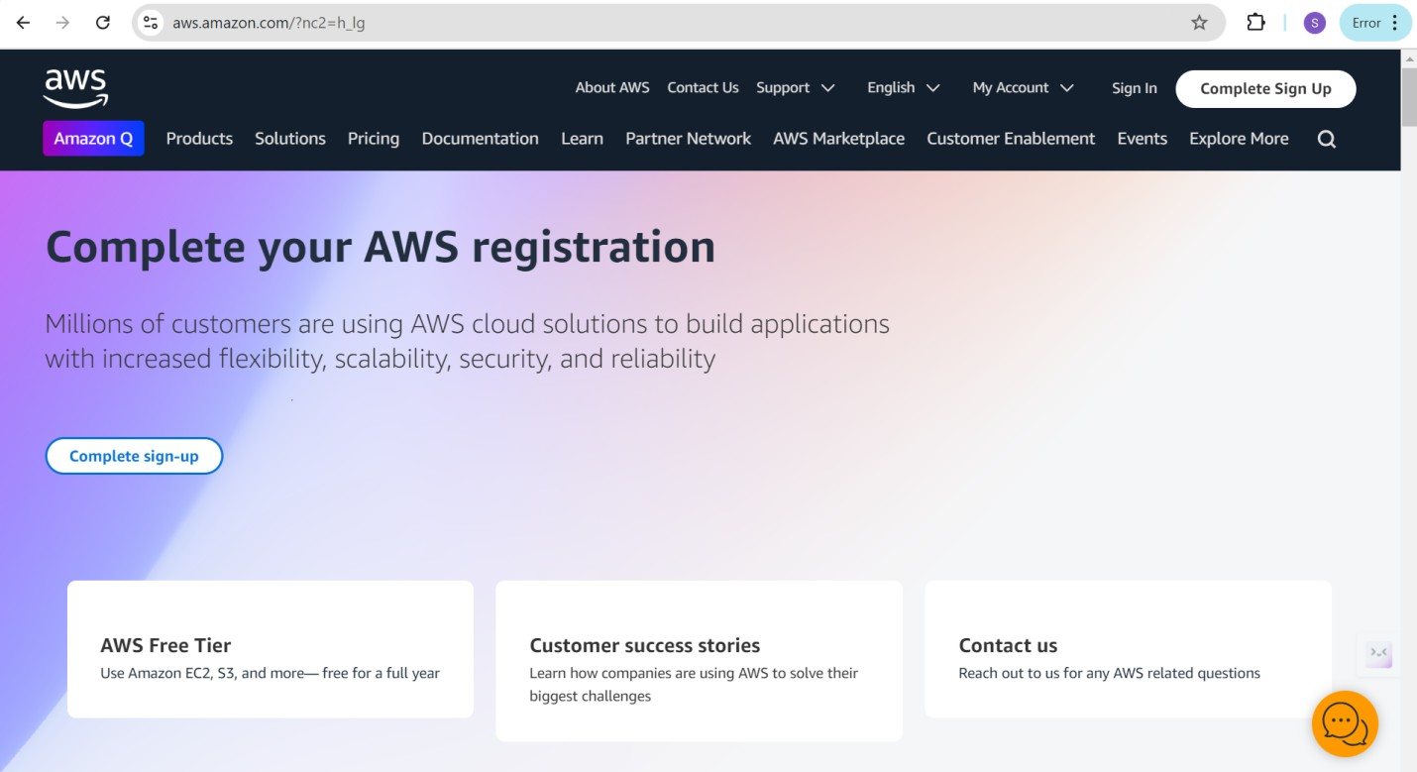

### Activity 1.2: Log in to the AWS Management Console

* + - After setting up your account, log in to the [AWS Management Console](https://aws.amazon.com/console/).

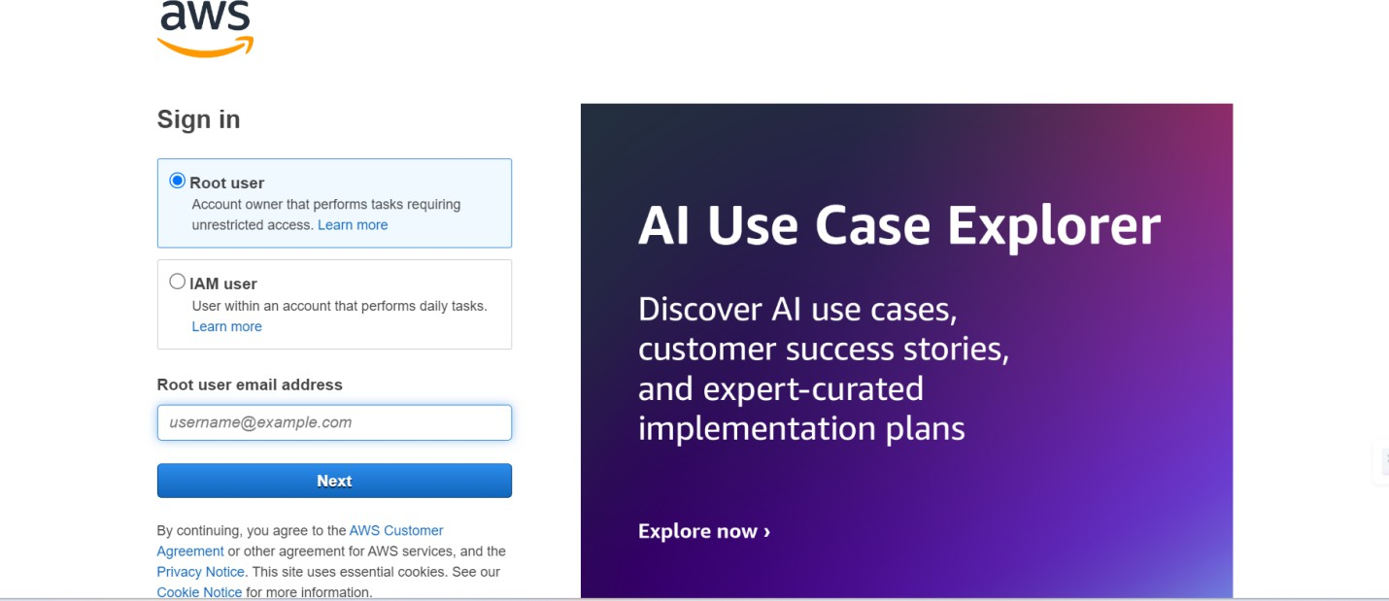

# Milestone 2: DynamoDB Database Creation and Setup

### Activity 2.1:Navigate to the DynamoDB

* + - In the AWS Console, navigate to DynamoDB and click on create tables.
    - 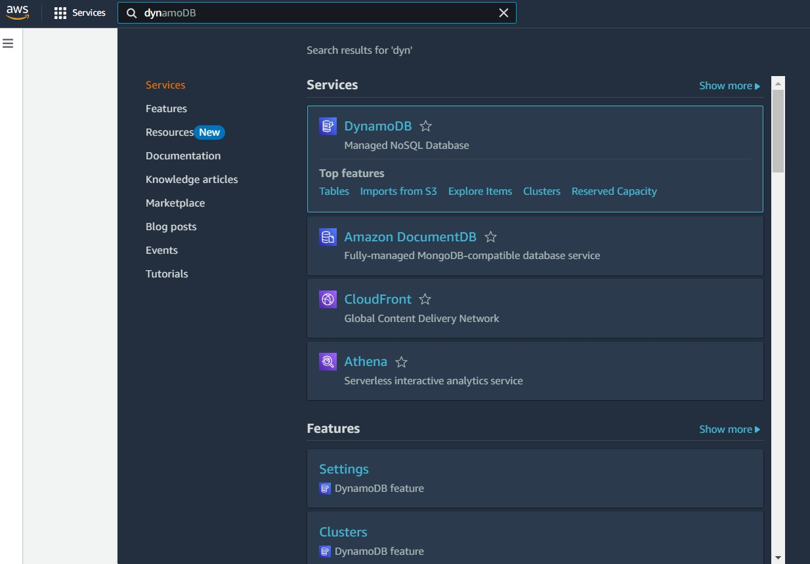

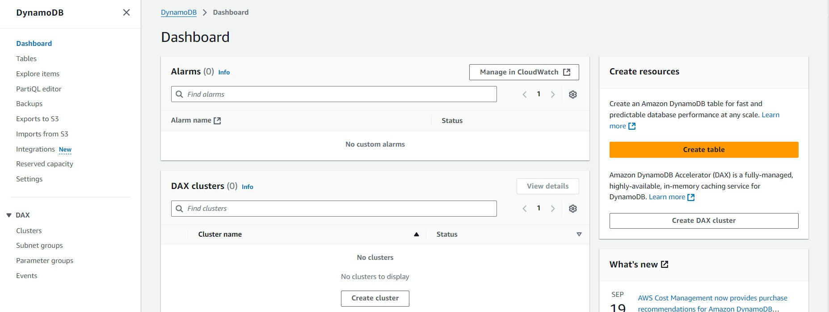

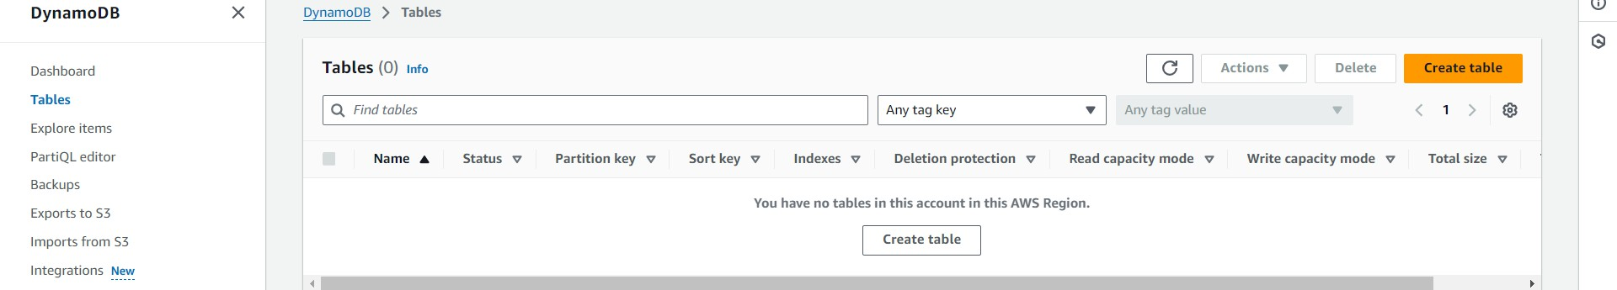

### Activity 2.2:Create a DynamoDB table for storing registration details and book requests.

* + - Create photographers table with partition key “photographer_id” with type String and click on create tables.

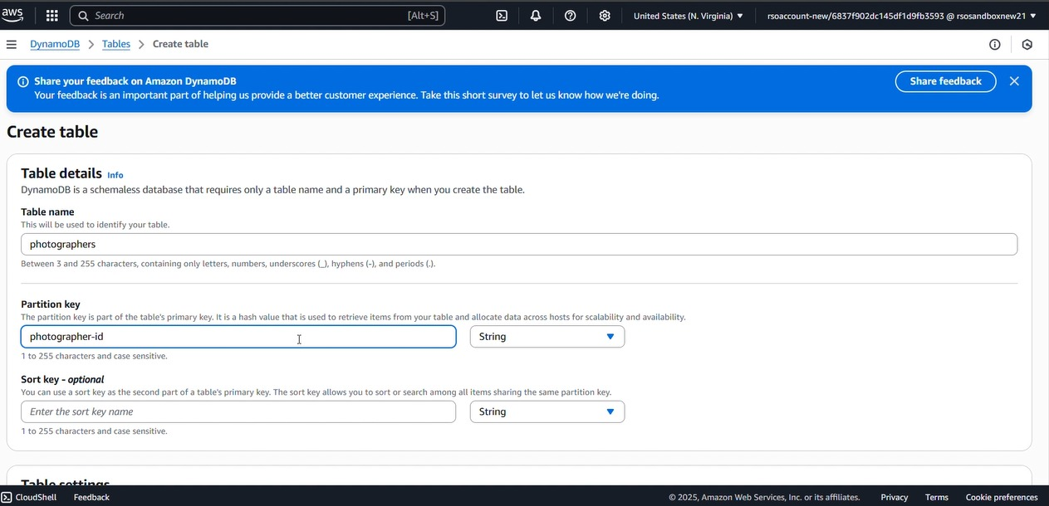

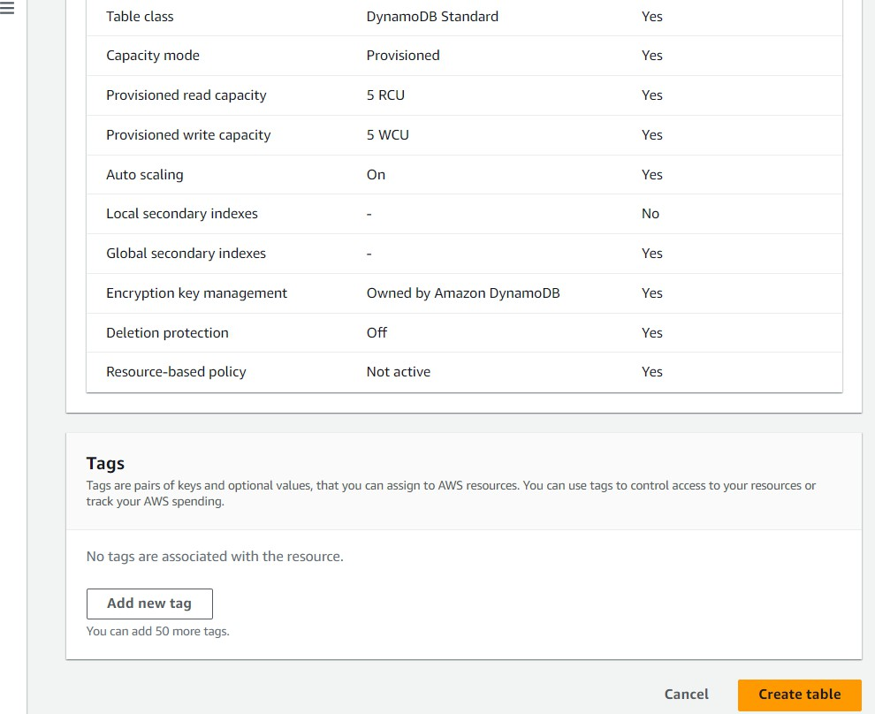

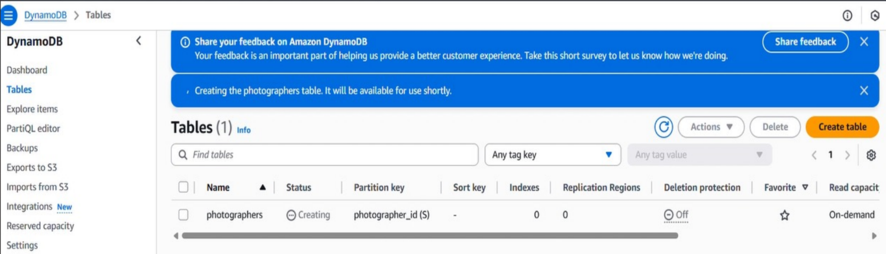

* + - Follow the same steps to create a requests table with photographer_id as the primary key for book requests data.

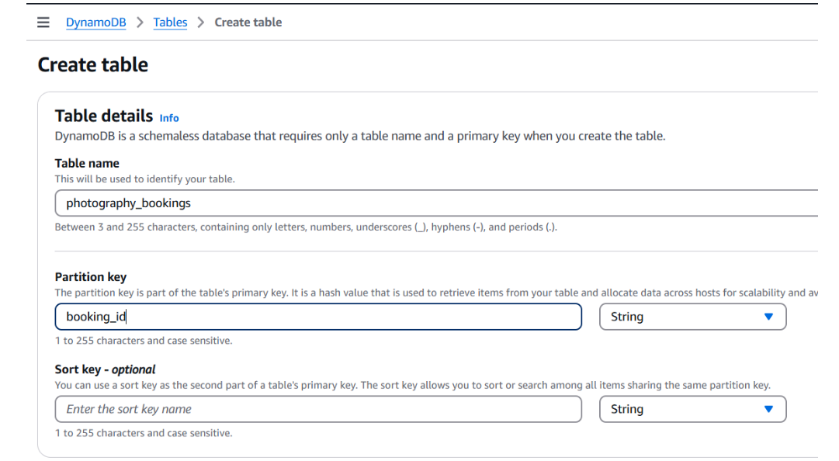

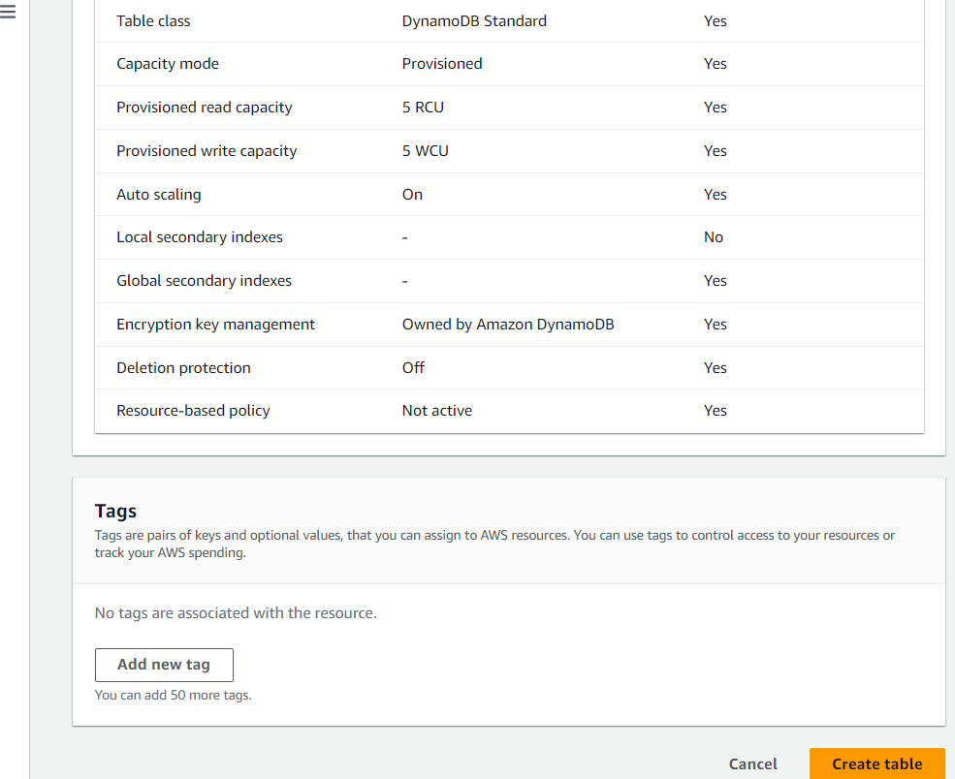

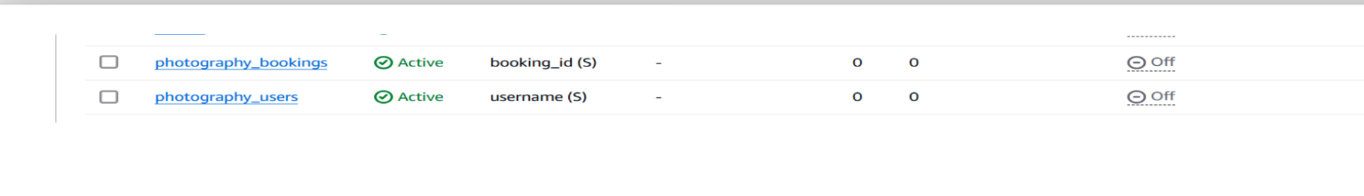

# Milestone 3:Backend Development and Application Setup

### Activity 3.1: Develop the backend using Flask

* + File Explorer Structure

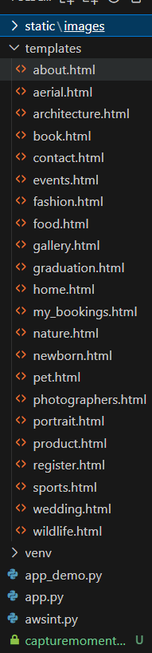

**Description:** Capture Moments is a photography booking platform that connects users with professional photographers for weddings, portraits, pets, and events. It offers easy booking, dynamic pricing, and a responsive UI. Built with Flask, HTML/CSS.

## Description of the code :

### Flask App Initialization





**Description:** initialize the Flask application instance using Flask( name ) to start building the web app.

### Dynamodb Setup:

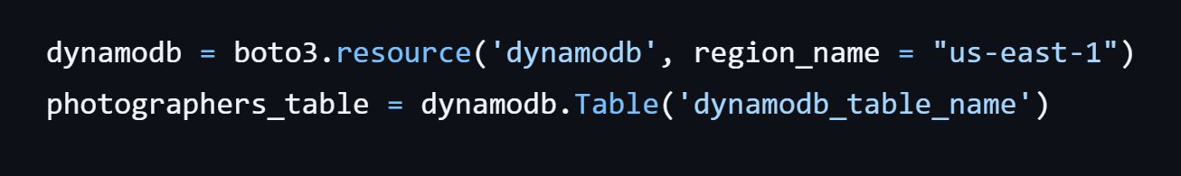

**Description:** initialize the DynamoDB resource for the us-east-1 region and set up access to the photographers table for storing details.

## Routes for Web Pages

### Home Route:

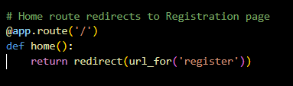

**Description:** define the home route / to automatically redirect users to the register page when they access the base URL

### Register Route:

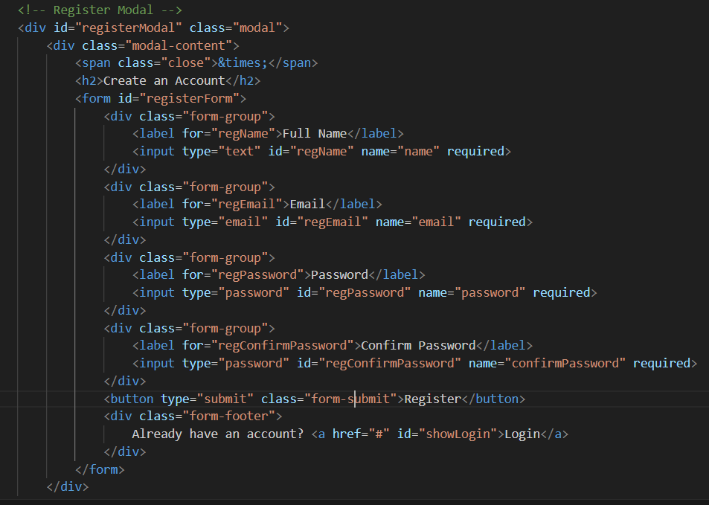

**Description:** define /register route to validate registration form fields, hash the user password using Bcrypt, store the new user in DynamoDB with a login count, and send an SNS notification on successful registration

### login Route (GET/POST):

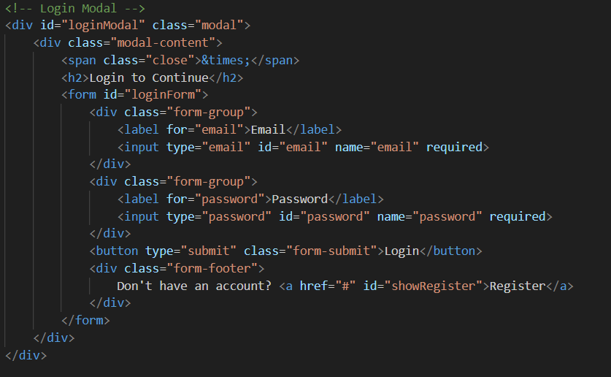

**Description:** define /login route to validate user credentials against DynamoDB, check the password using Bcrypt, update the login count on successful authentication, and redirect users to the home page

### photography services routes:

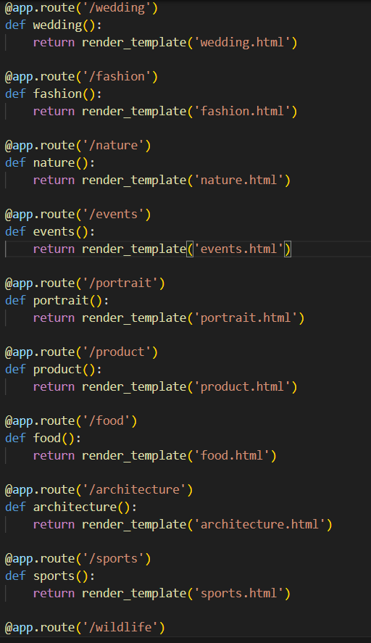

**Description:** Our photography website features a streamlined navigation with three key sections: the homepage (/) showcasing our portfolio and services, service selection buttons (/service-buttons) for choosing categories like *Wedding* or *Portrait*, and dynamic service pages (/<service>.html) that display tailored content for each photography style. This ensures an intuitive and engaging user experience.

* **Book a photographer route:**
* 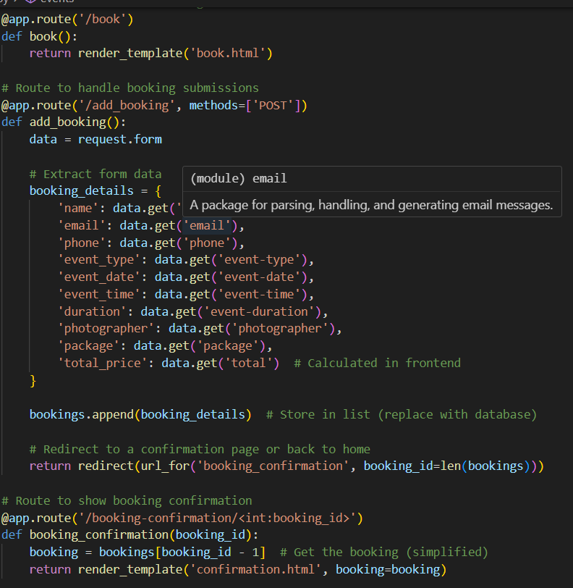

**Description**: Our seamless booking system connects you with professional photographers tailored to your needs. Browse portfolios, check availability, and secure your session in just a few clicks. Whether it's portraits, events, or commercial shoots, we ensure the perfect match for your vision. Flexible packages and instant confirmations make capturing your moments effortless.

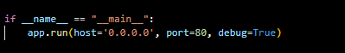**Deployment Code:**

.

**Description:** start the Flask server to listen on all network interfaces (0.0.0.0) at port 80

with debug mode enabled for development and testing

# Milestone 5: IAM Role Setup

### Activity 5.1:Create IAM Role.

* + In the AWS Console, go to IAM and create a new IAM Role for EC2 to interact with DynamoDB .

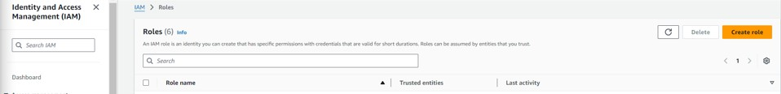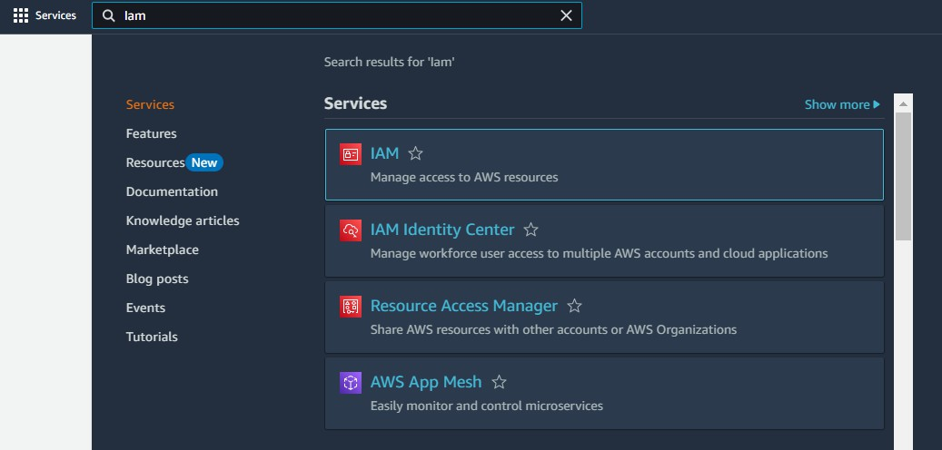

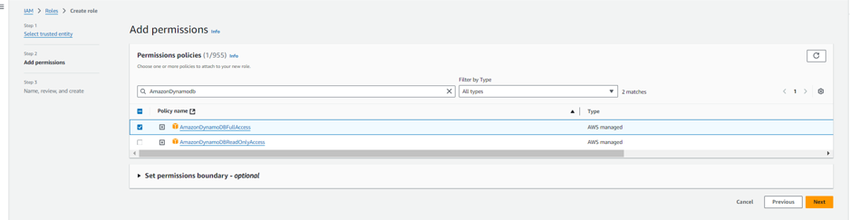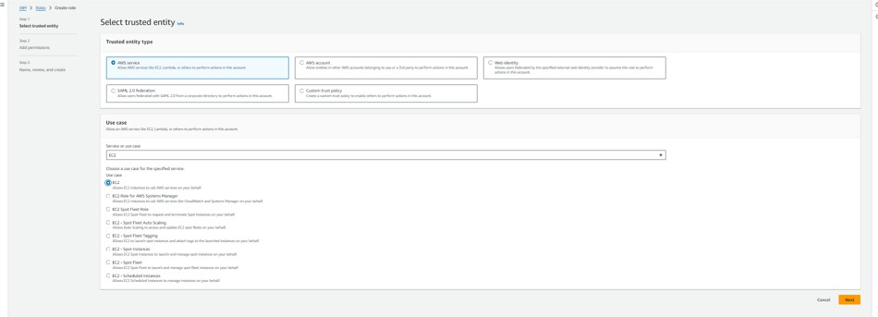

### Activity 5.2: Attach Policies.

Attach the following policies to the role:

* Amazon DynamoDB Full Access: Allows EC2 to perform read/write operations on DynamoDB.

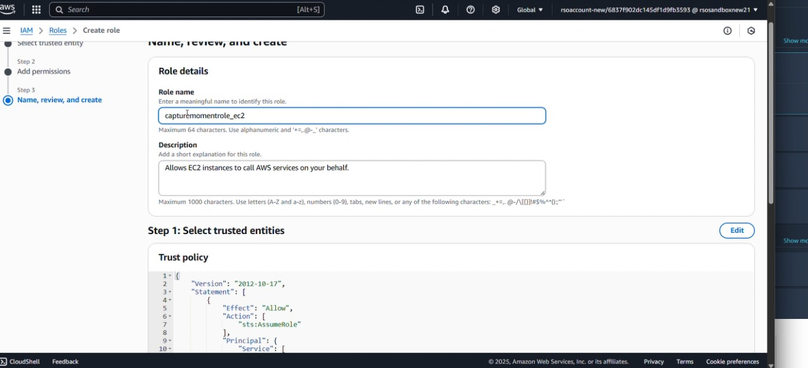

# Milestone 6: EC2 Instance Setup

* **Note: Load your Flask app and Html files into GitHub repository.**

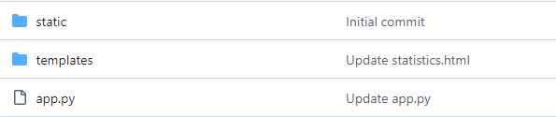

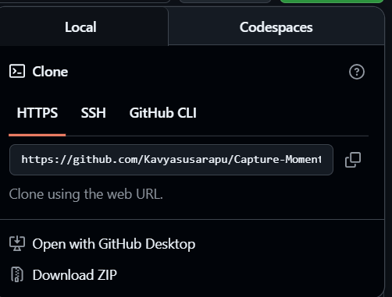

### Activity 6.1: Launch an EC2 instance to host the Flask application.

* + **Launch EC2 Instance**
    - In the AWS Console, navigate to EC2 and launch a new instance.
* Click on Launch instance to launch EC2 instance
* Click on Launch instance to launch EC2 instance

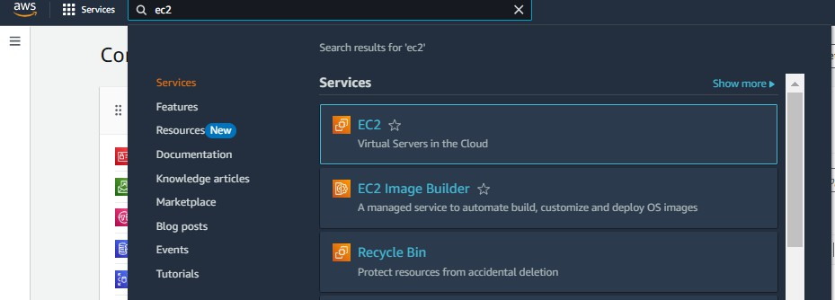

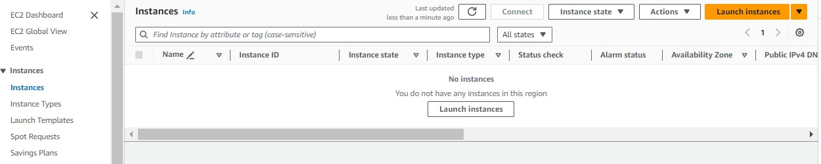

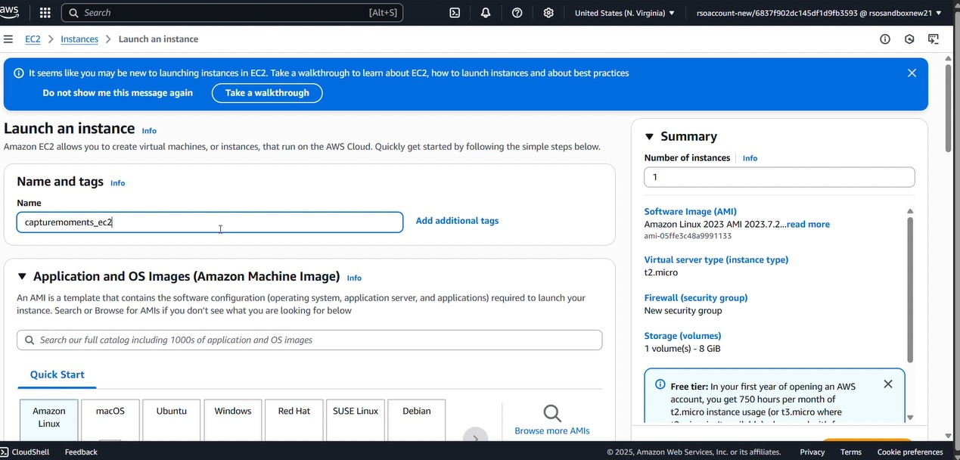

* + Choose Amazon Linux 2 or Ubuntu as the AMI and t2.micro as the instance type (free-tier eligible).

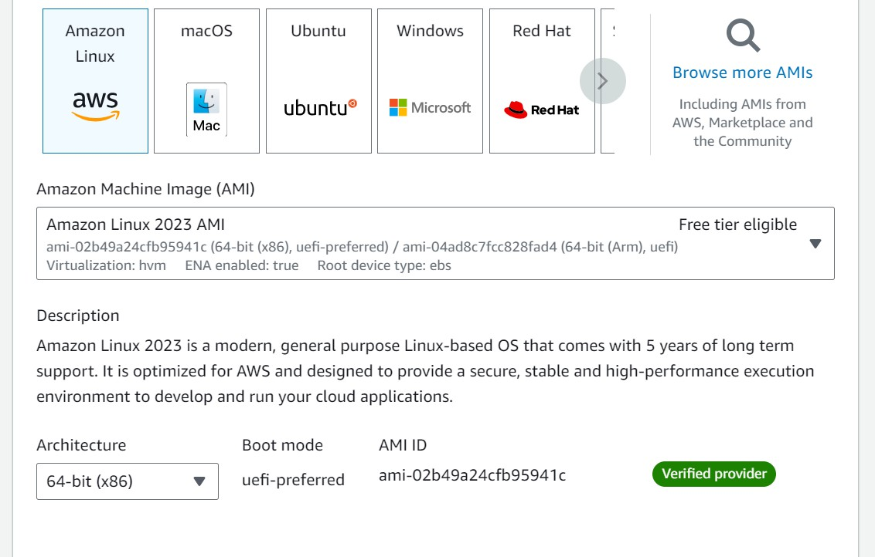

* 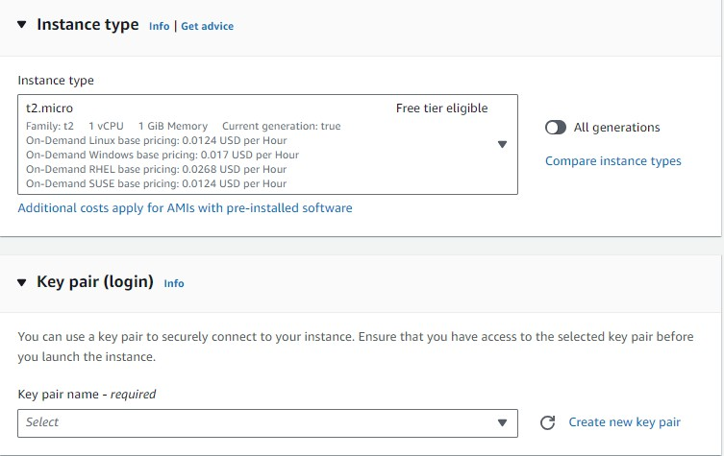Create and download the key pair for Server access.

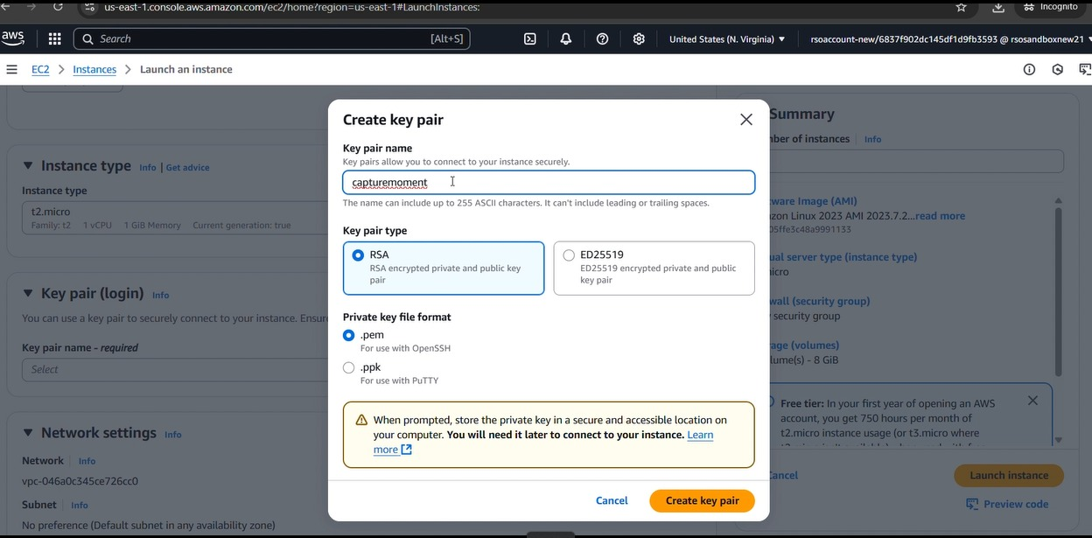

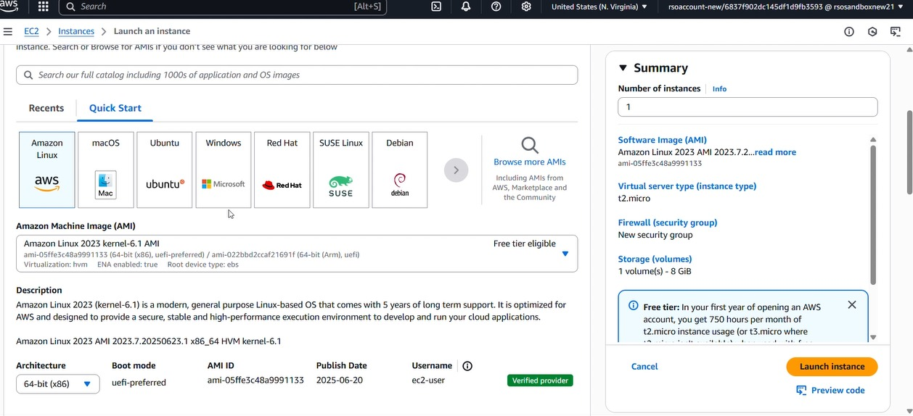

### Activity 6.2:Configure security groups for HTTP, and SSH access.

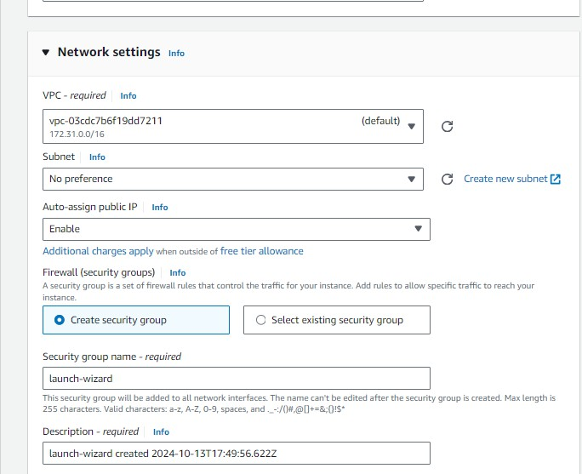

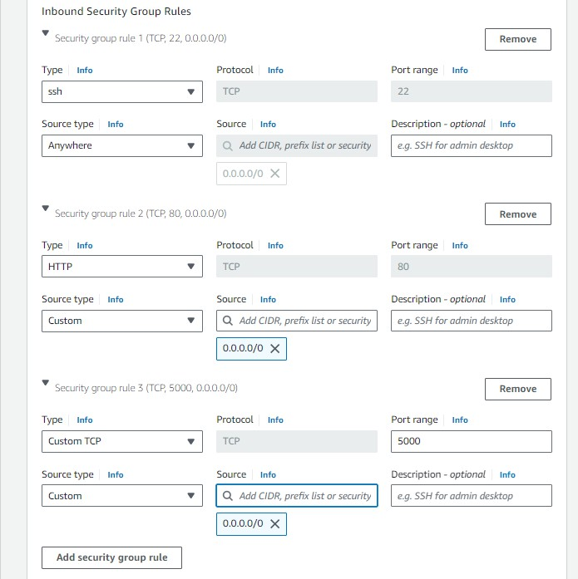

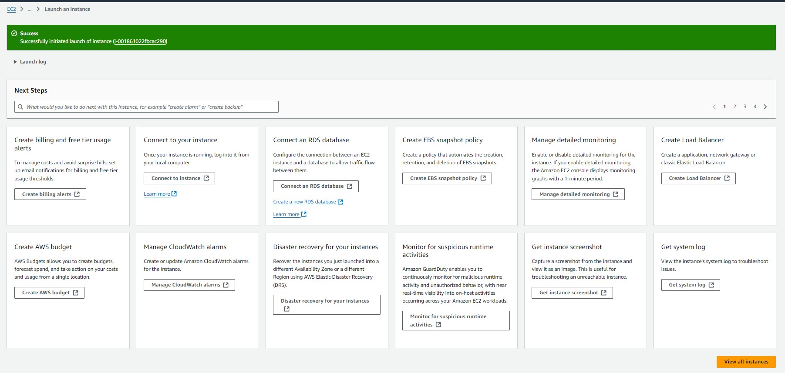

* To connect to EC2 using **EC2 Instance Connect**, start by ensuring that an **IAM role** is attached to your EC2 instance. You can do this by selecting your instance, clicking on **Actions**, then navigating to **Security** and selecting **Modify IAM Role** to attach the appropriate role. After the IAM role is connected, navigate to the **EC2** section in the **AWS Management Console**. Select the **EC2 instance** you wish to connect to. At the top of the **EC2 Dashboard**, click the **Connect** button. From the connection methods presented, choose **EC2 Instance Connect**. Finally, click **Connect** again, and a new browser-based terminal will open, allowing you to access your EC2 instance directly from your browser.

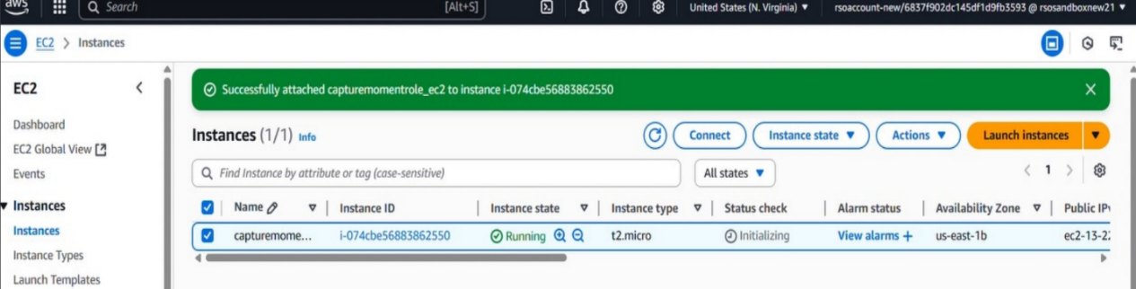

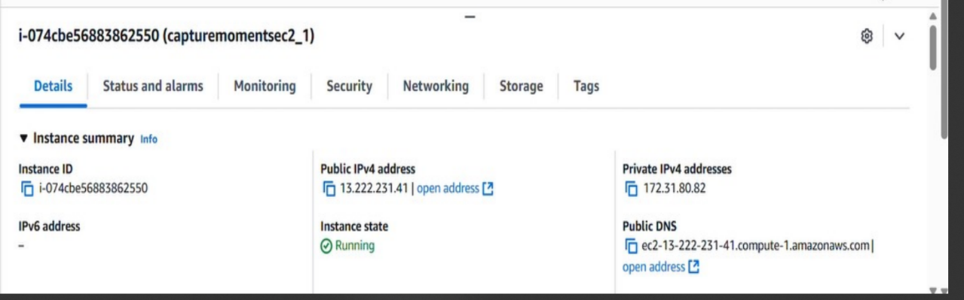

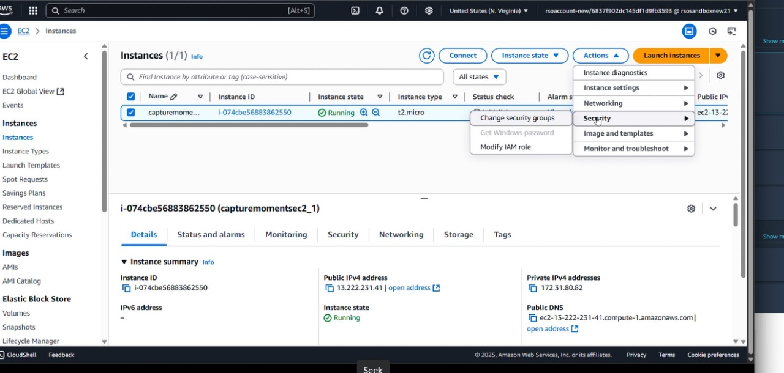

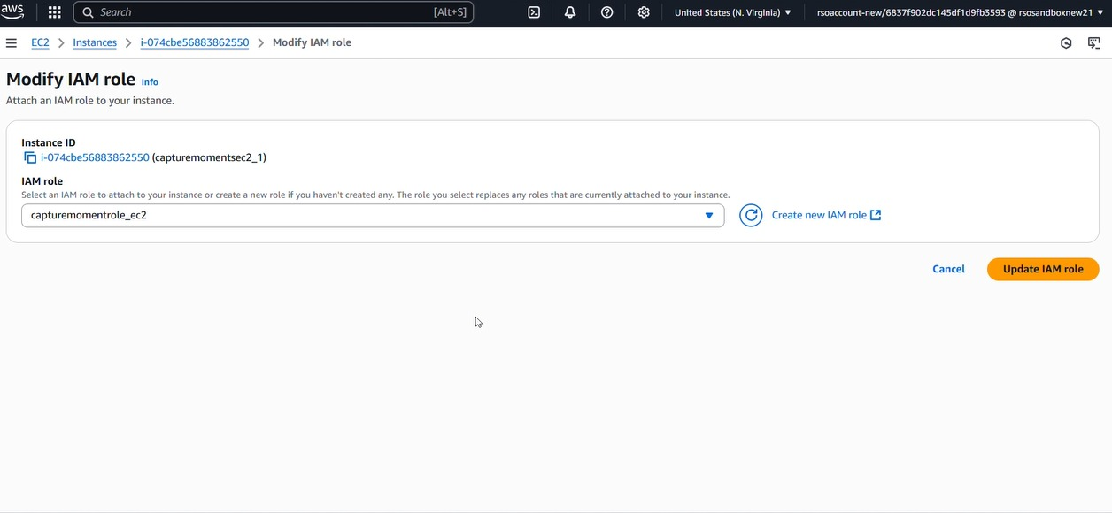

* Now connect the EC2 with the files

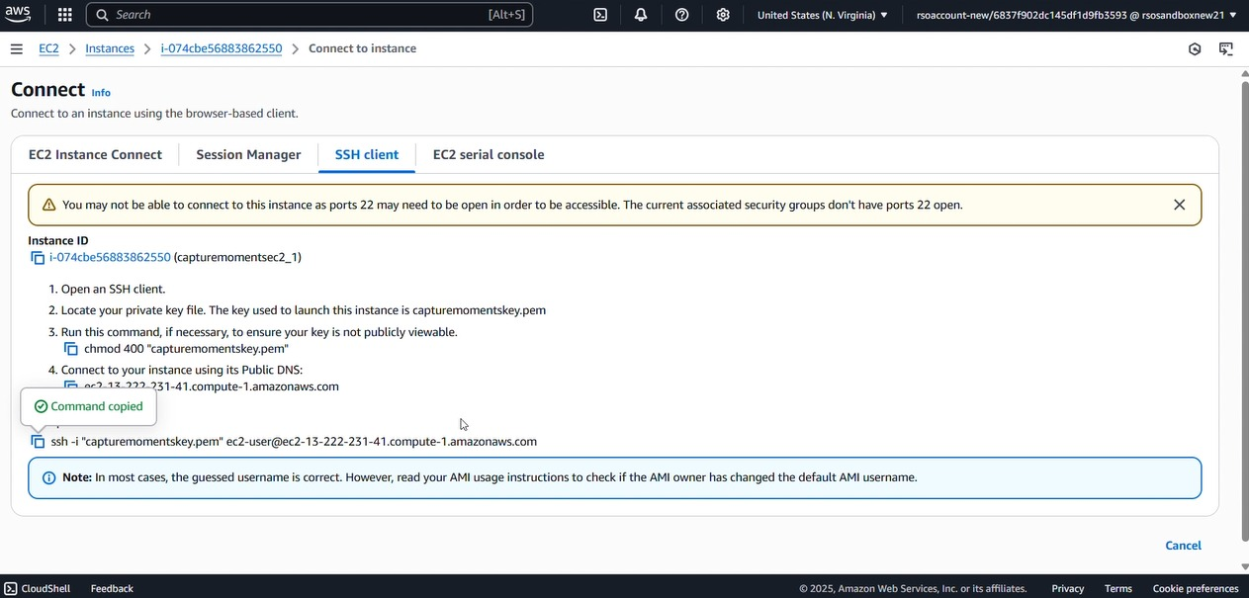

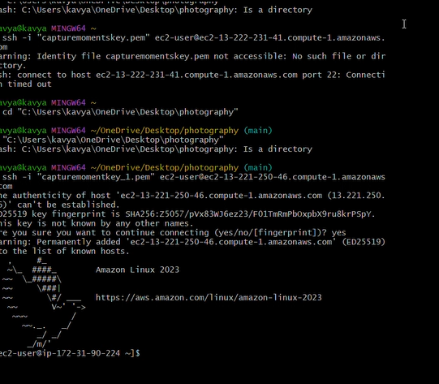

**Milestone 7: Deployment on EC2**

### Activity 7.1: Install Software on the EC2 Instance

Install Python3, Flask, and Git: On Amazon Linux 2:

sudo yum update -y

sudo yum install python3 git sudo pip3 install flask boto3

Verify Installations:

flask --version git --version

### Activity 7.2:Clone Your Flask Project from GitHub

**Clone your project repository from GitHub into the EC2 instance using Git.**

Run: ‘git clone **https://github.com/Kavyasusarapu/Capture-Moment.git**

Note: change your-github-username and your-repository-name with your credentials here: ‘git clone https://github.com/AlekhyaPenubakula/InstantLibrary.git’

* This will download your project to the EC2 instance.

### To navigate to the project directory, run the following command:

Cd C:\Users\kavya\OneDrive\Desktop\photography

### Once inside the project directory, configure and run the Flask application by executing the following command with elevated privileges:

**Run the Flask Application**

sudo flask run --host=0.0.0.0 --port=80

**Verify the Flask app is running**: [http://your-ec2-public-ip](http://your-ec2-public-ip/)

* Run the Flask app on the EC2 instance

### Access the website through:

**Public IPs:** <https://13.221.250.46:5000/>

## Milestone 8: Testing and Deployment:

### Activity 8.1: Conduct functional testing to verify user registration, login, book a photographer and photographer services.

* **Login Page:**

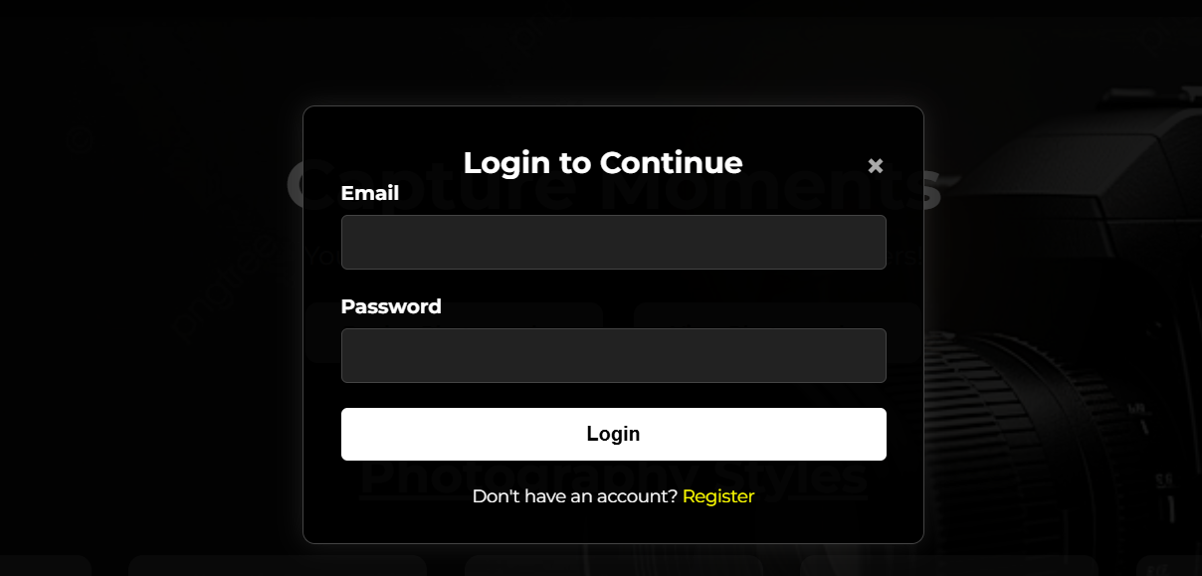

**Registration page:**

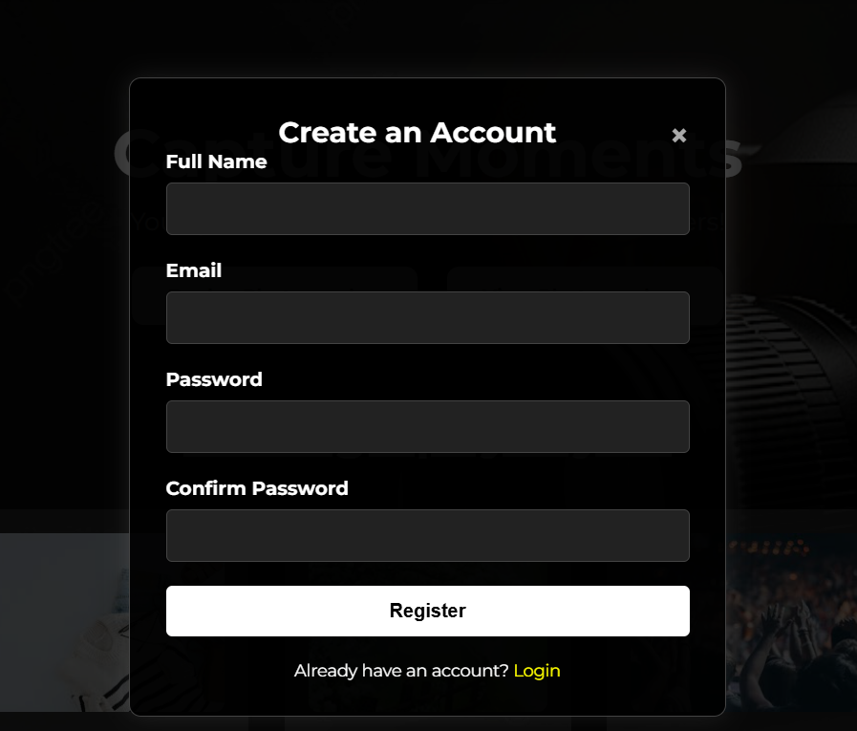

**Home page:**

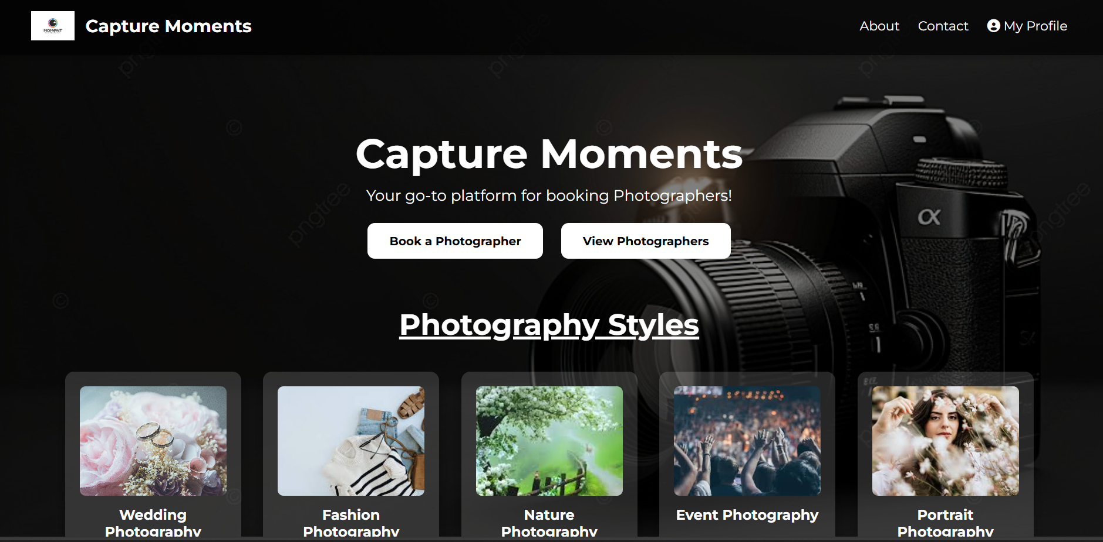

**About capture moments page:**

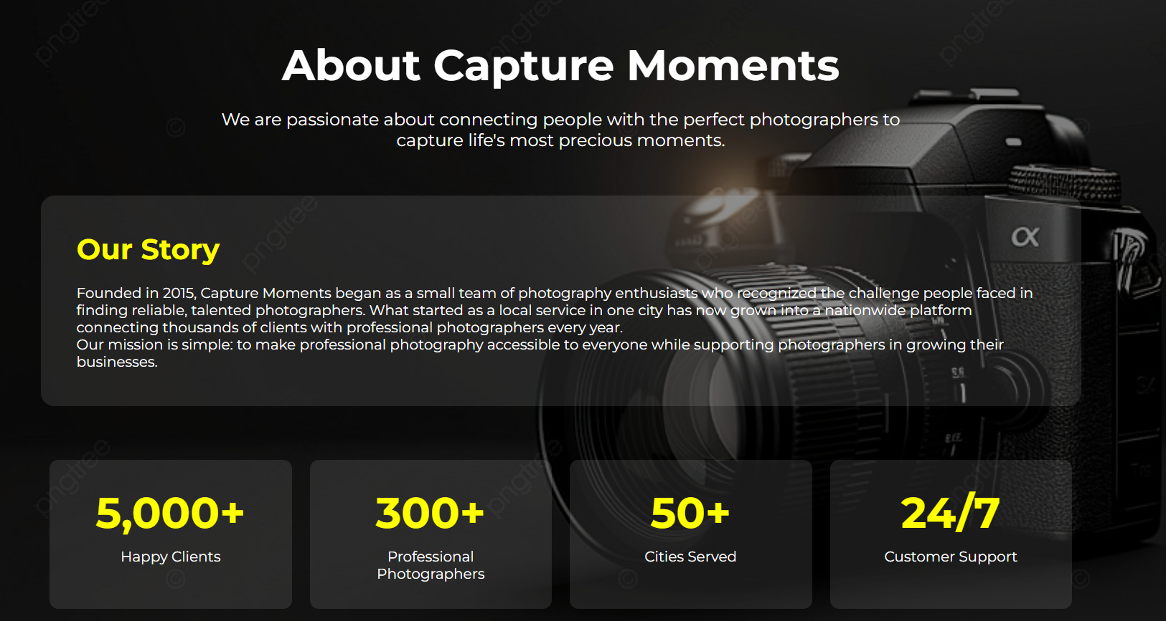

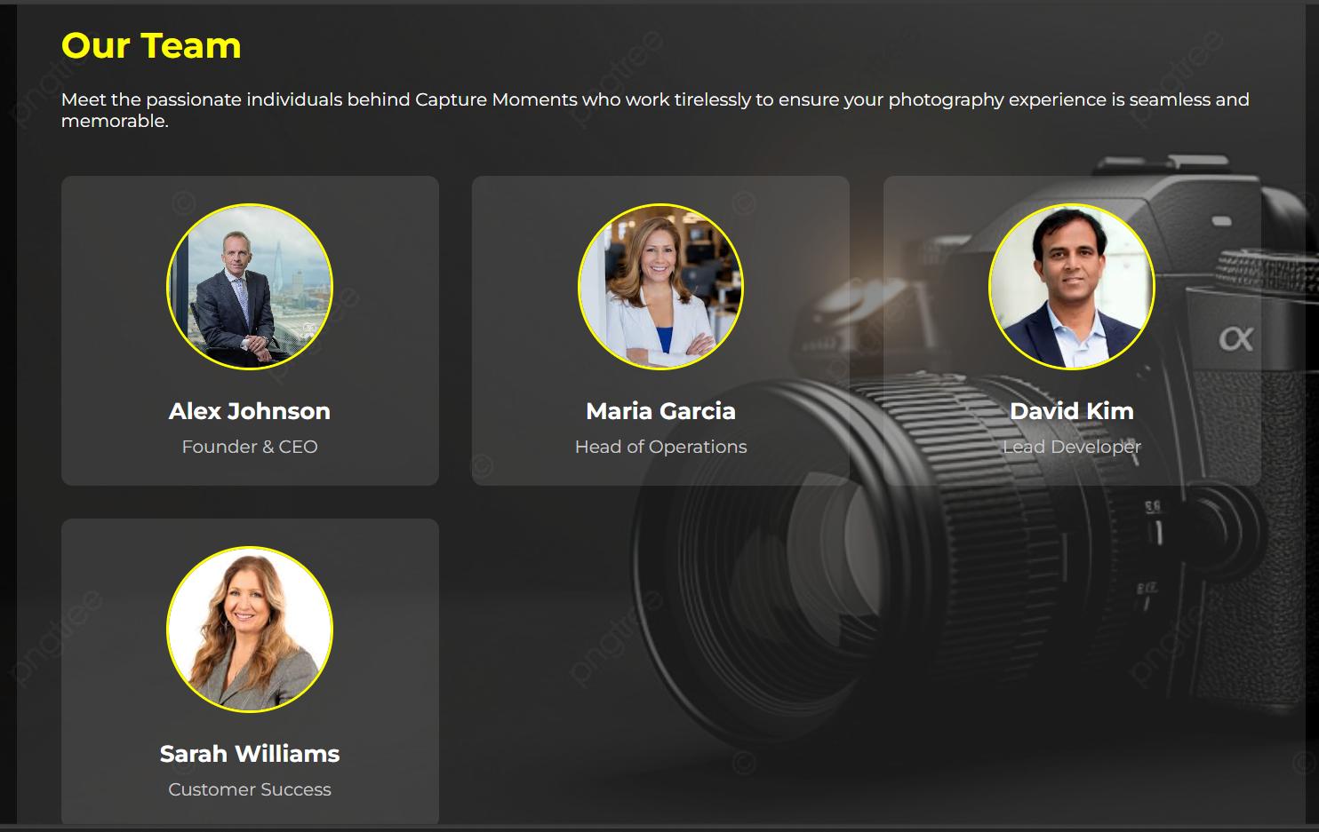

**Contact us page:**

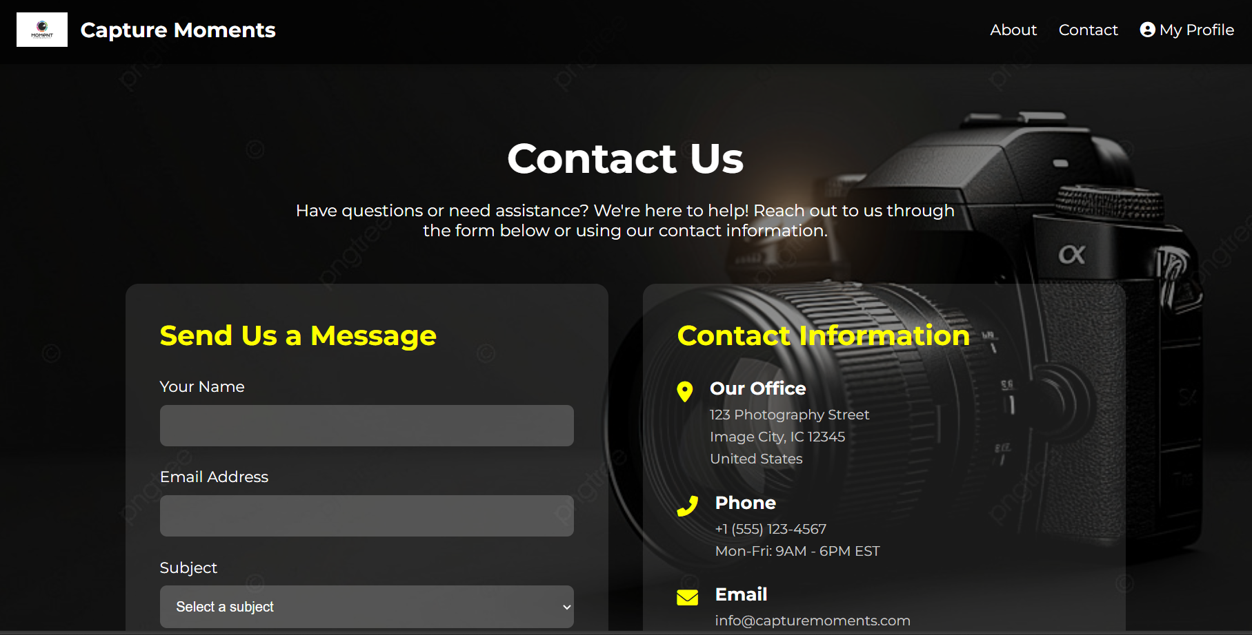

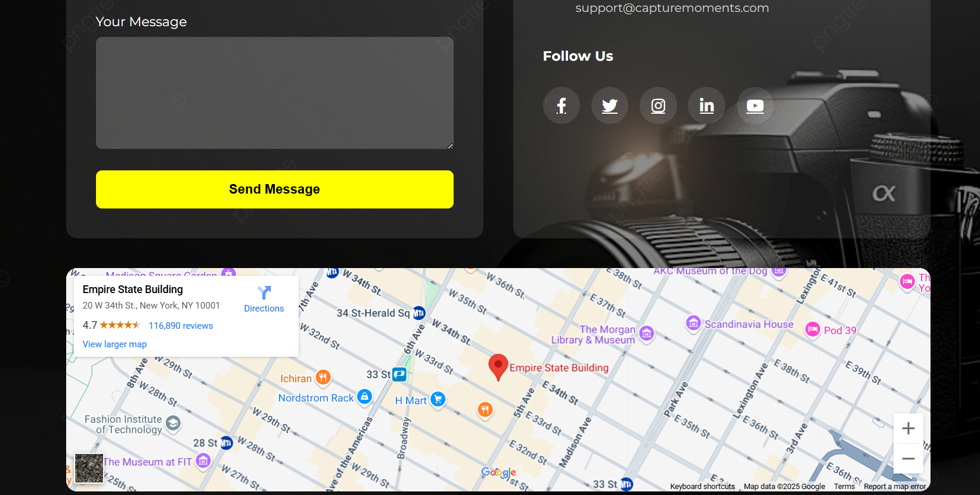

**Book a photographer session:**

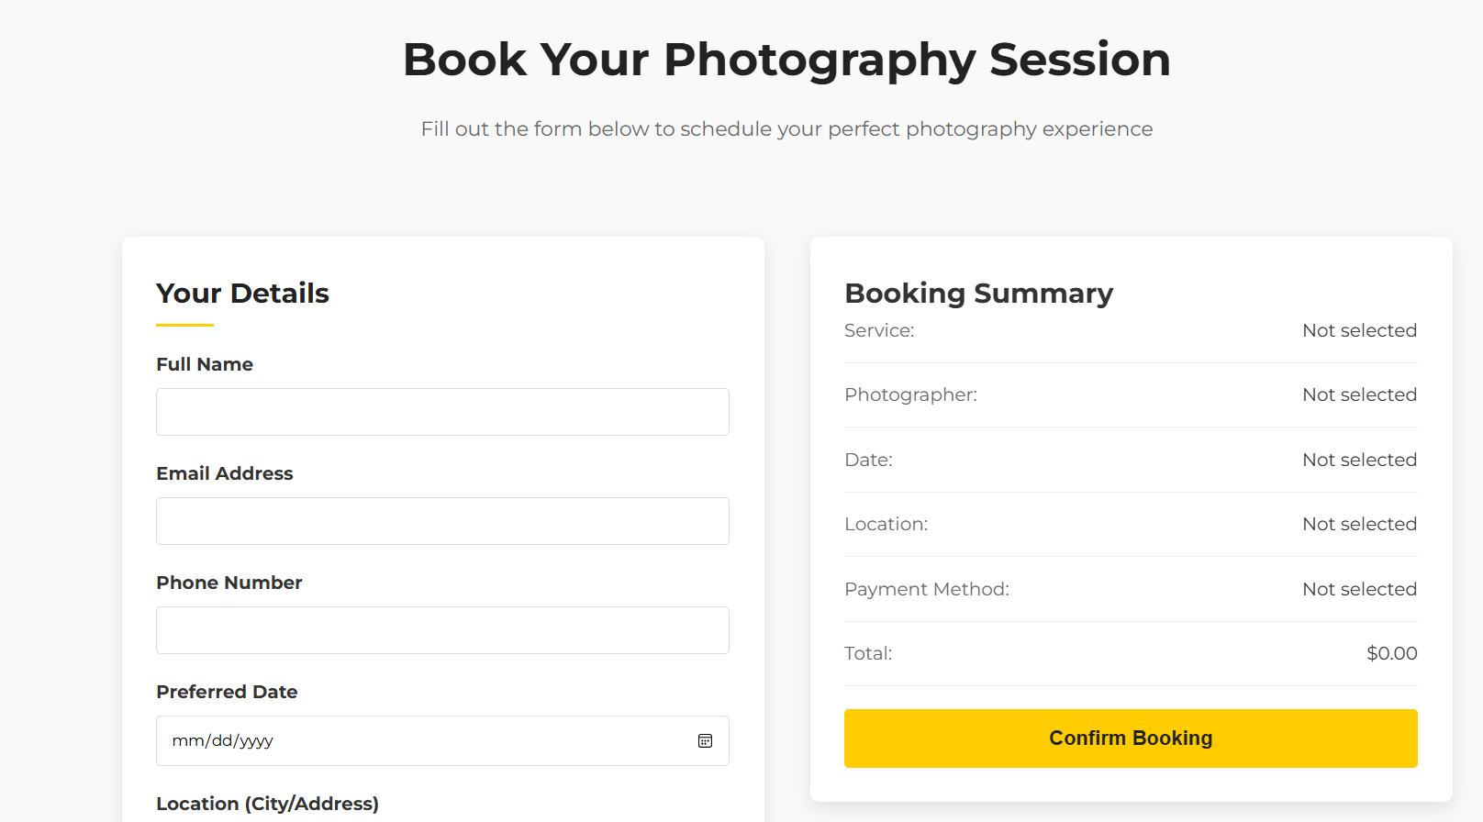

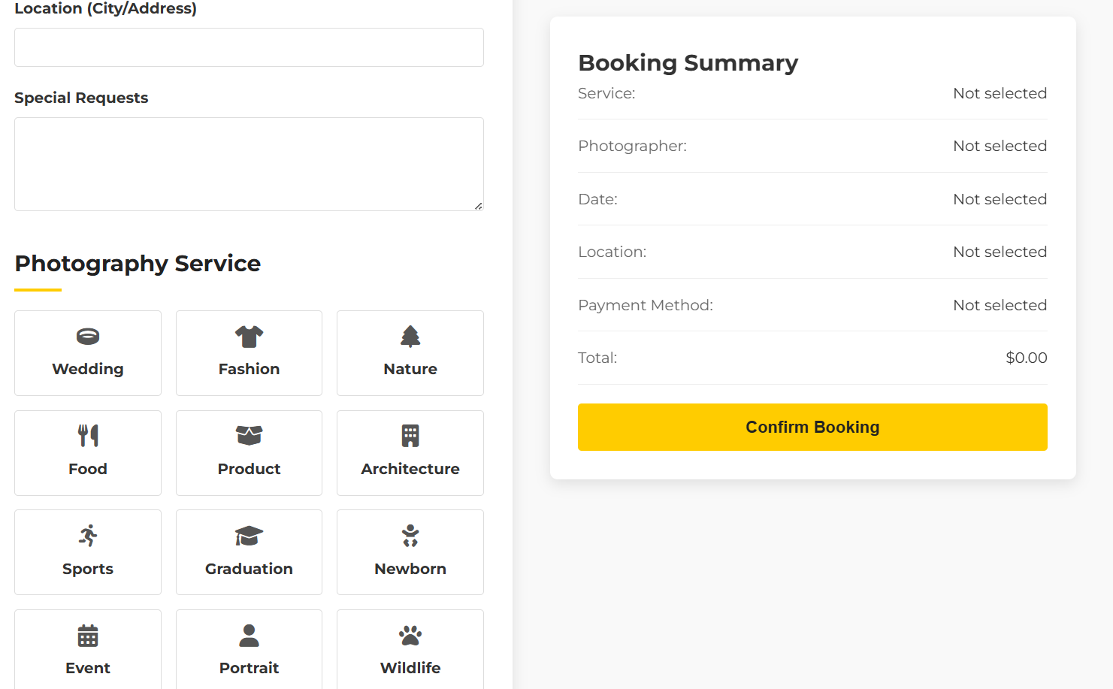

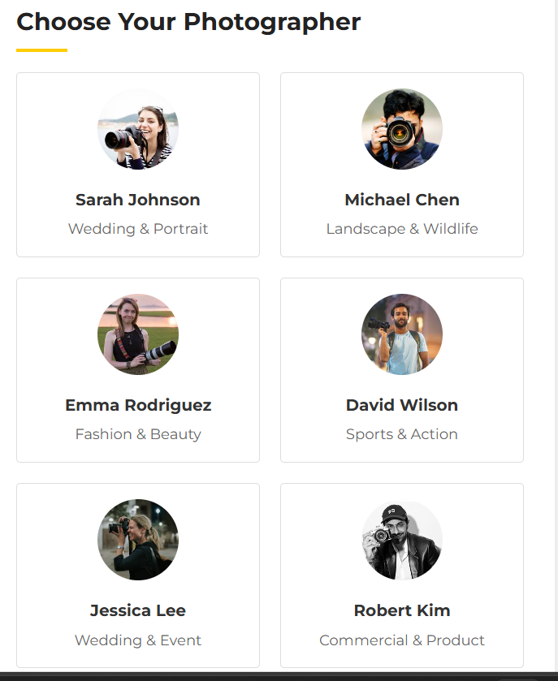 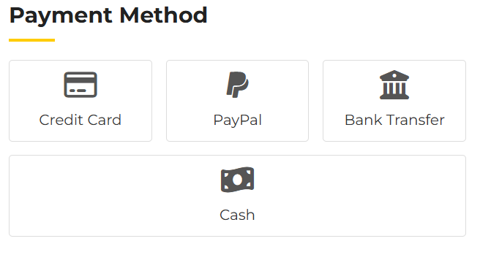

**Photography services:**

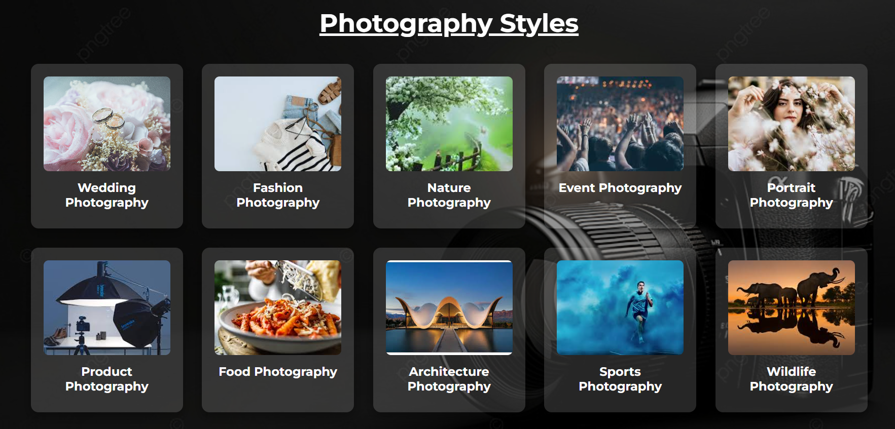

**Testimonials:**

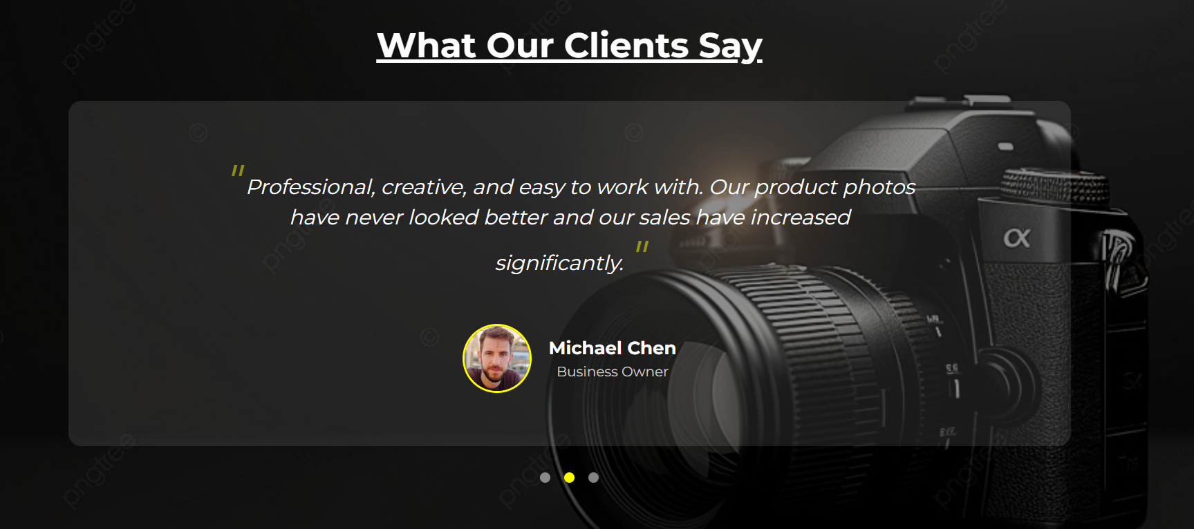

**Footer:**

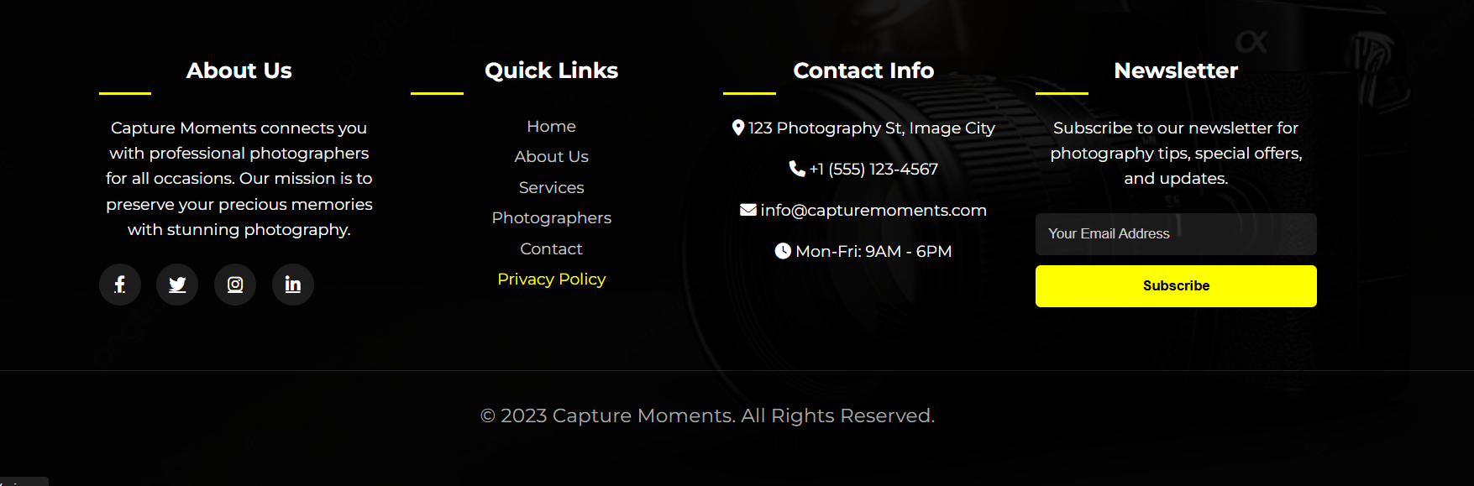

**Services page:**



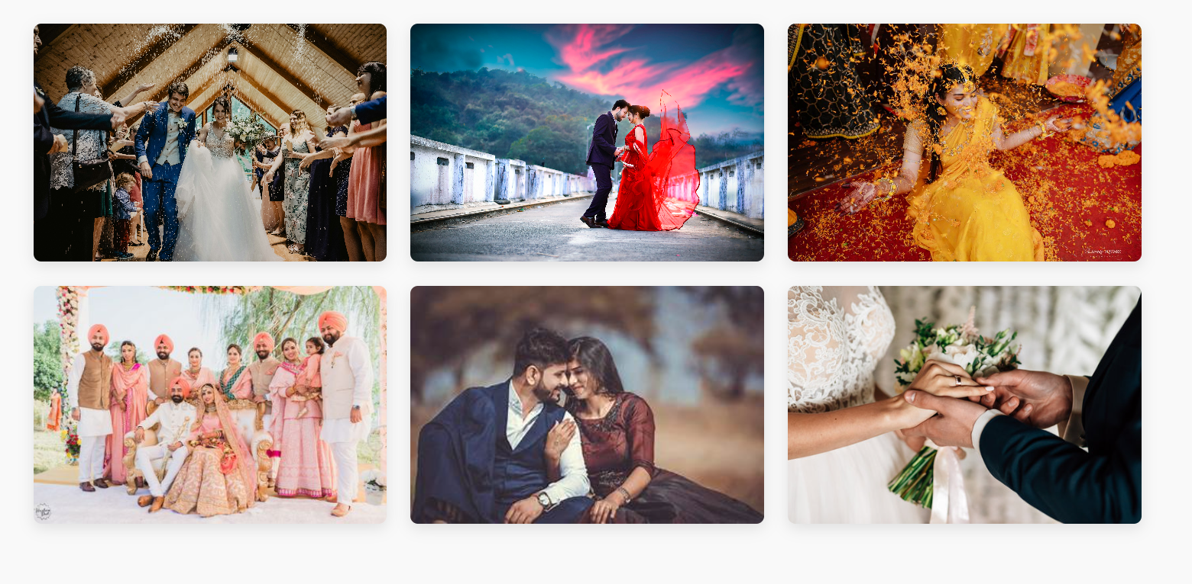



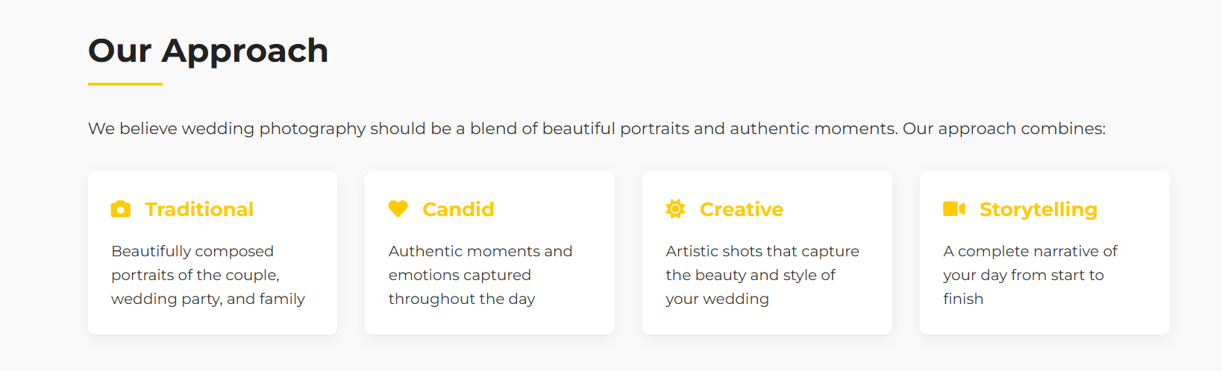

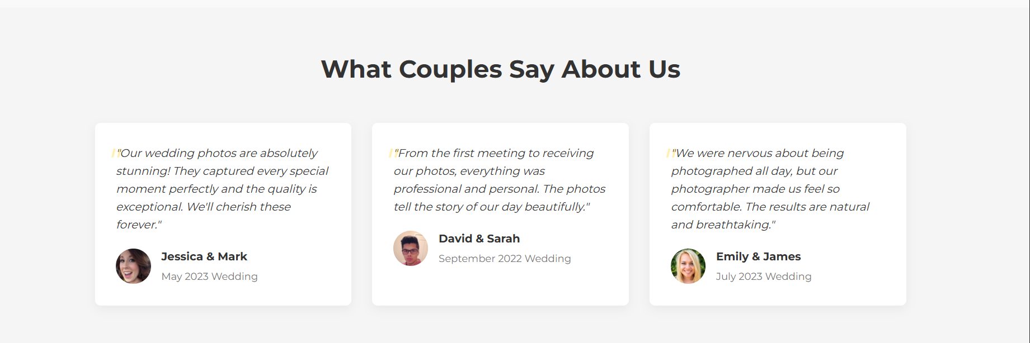

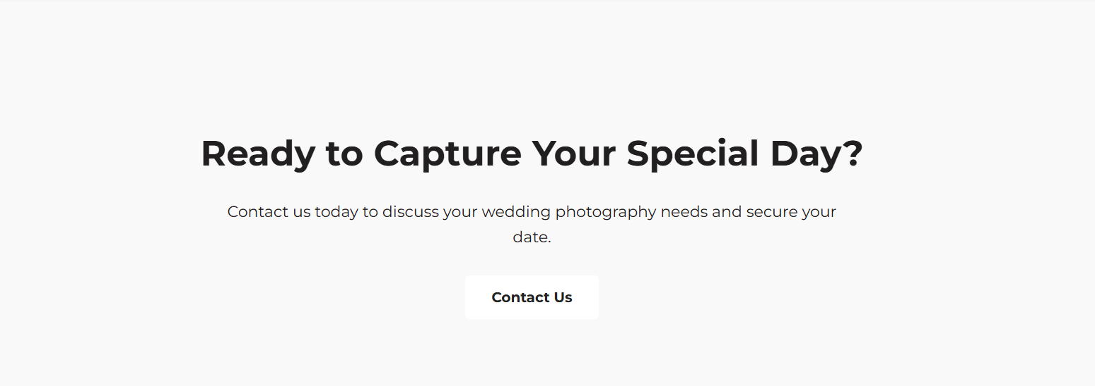

**My bookings page:**

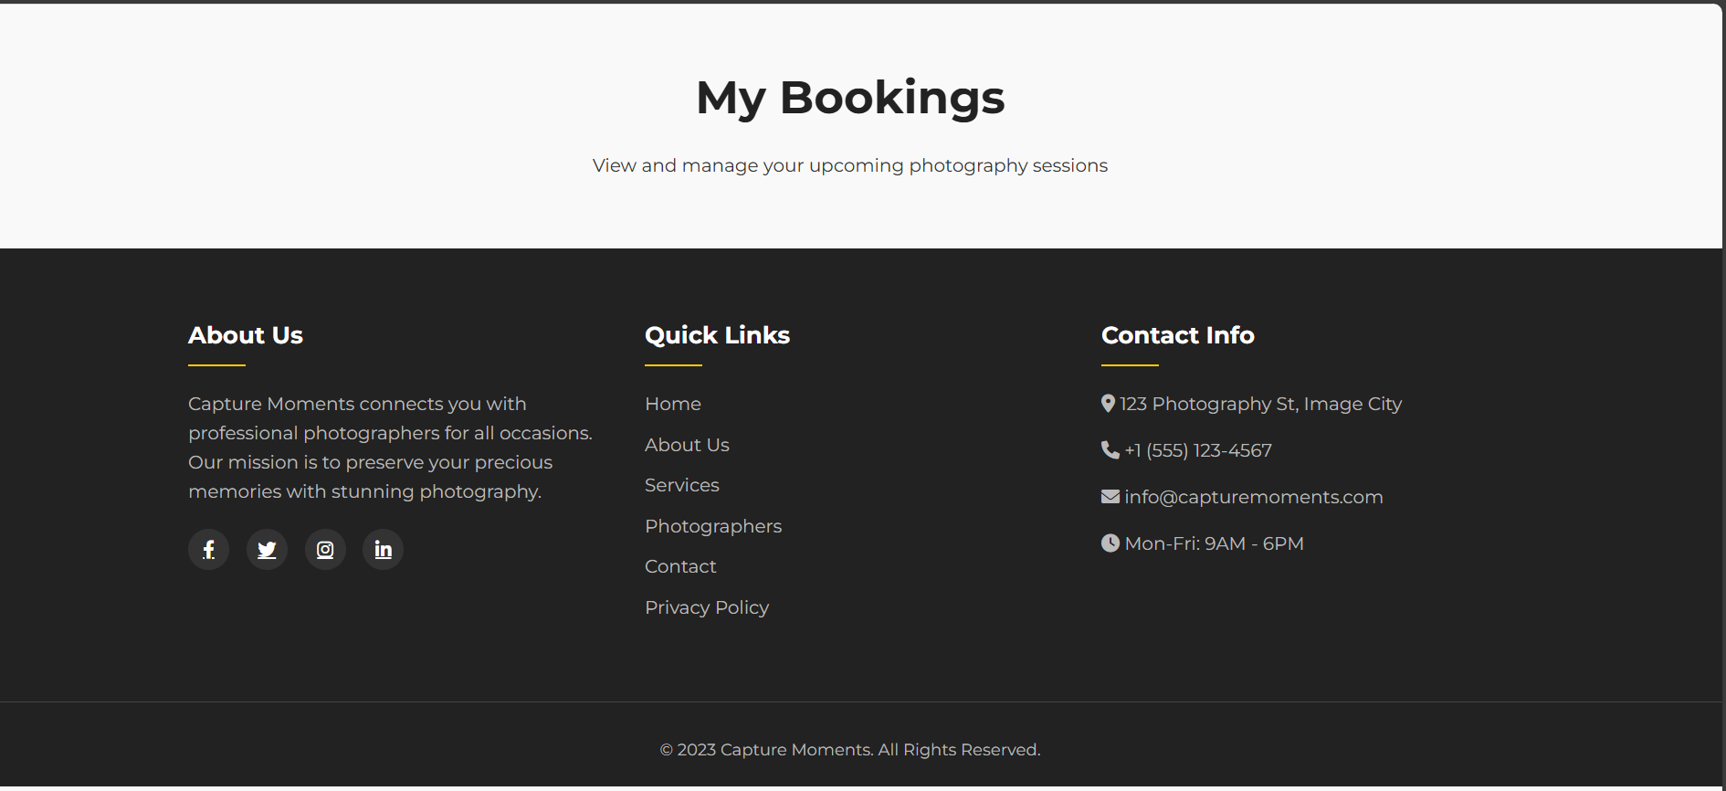

**Logout:**

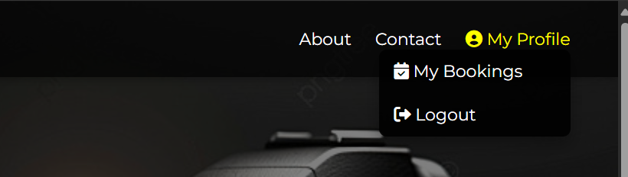



**View photographers:**

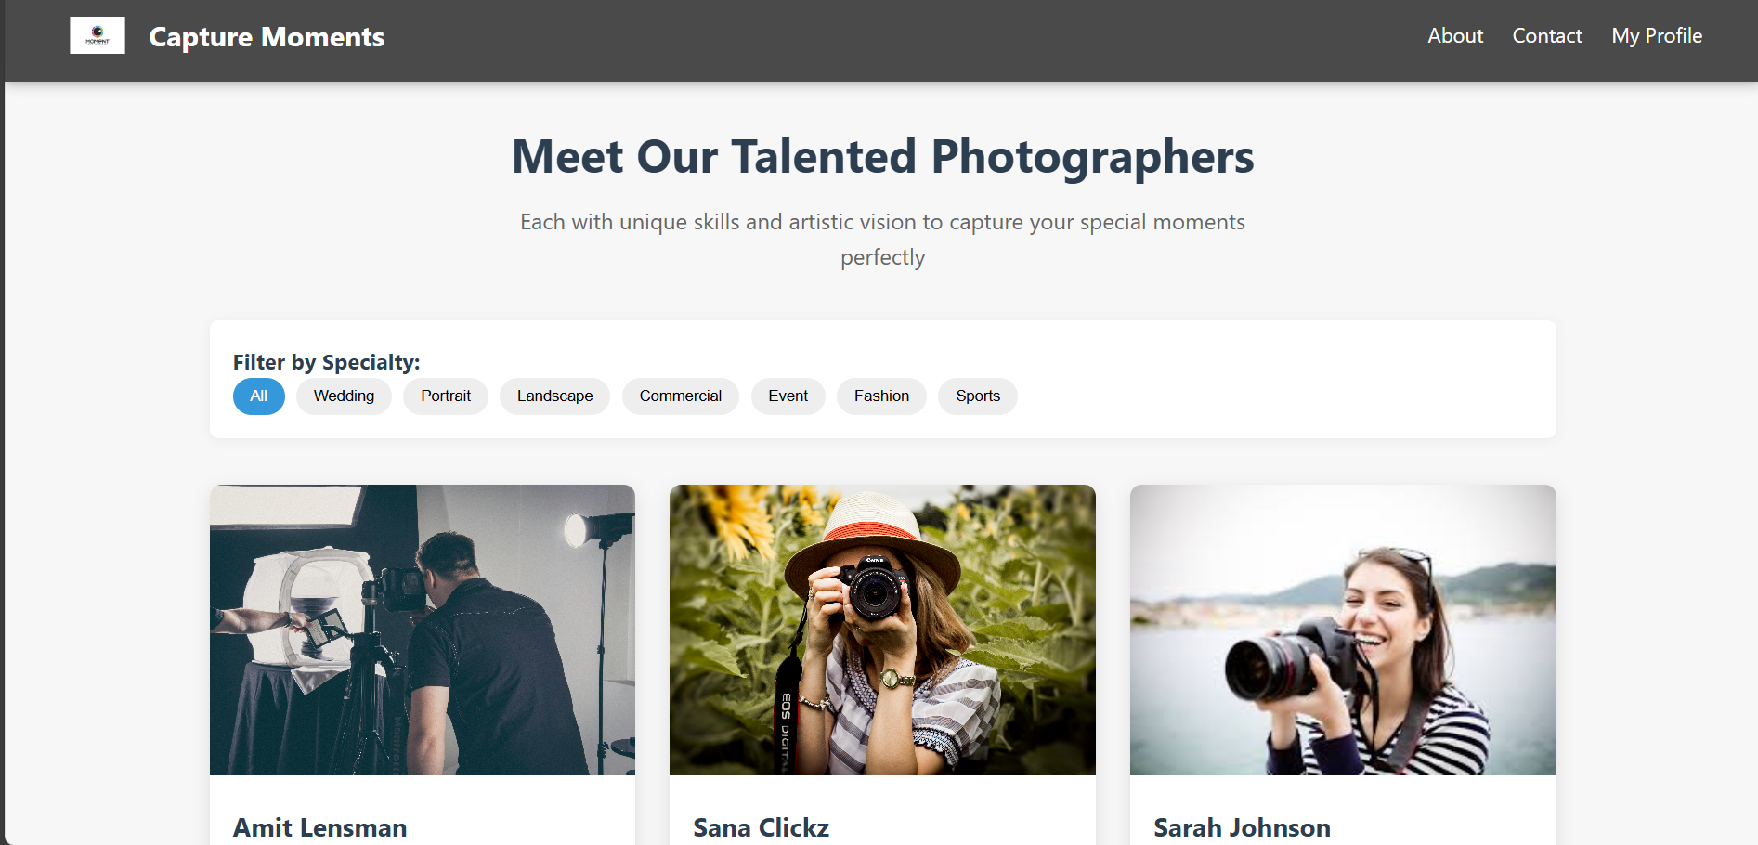

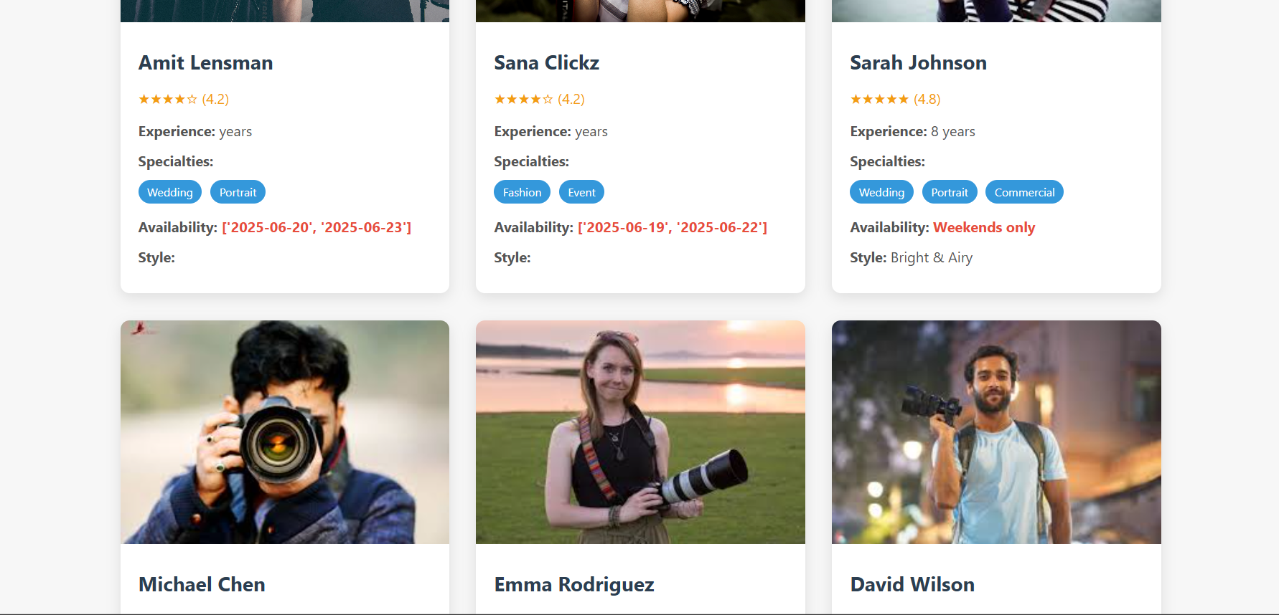

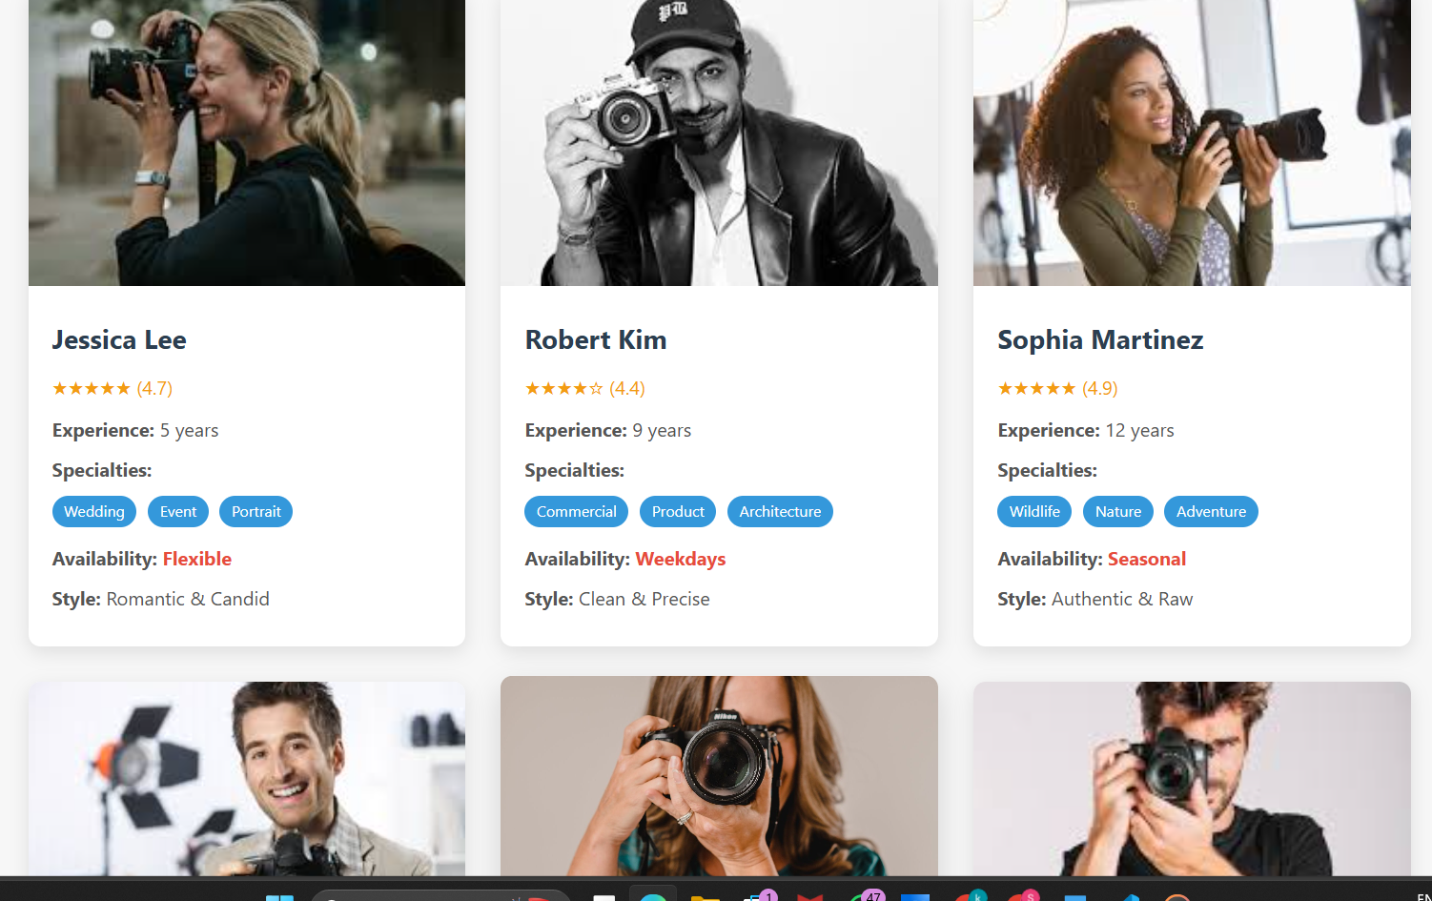

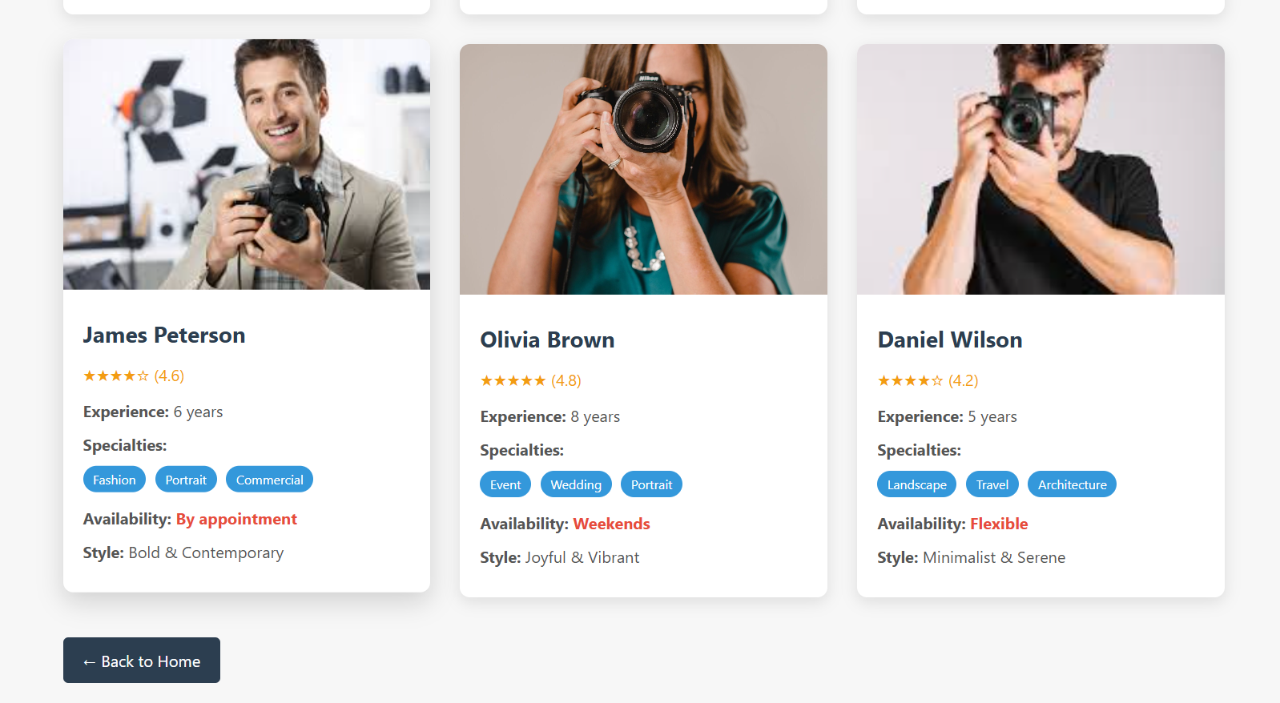

**Booking confirmation:**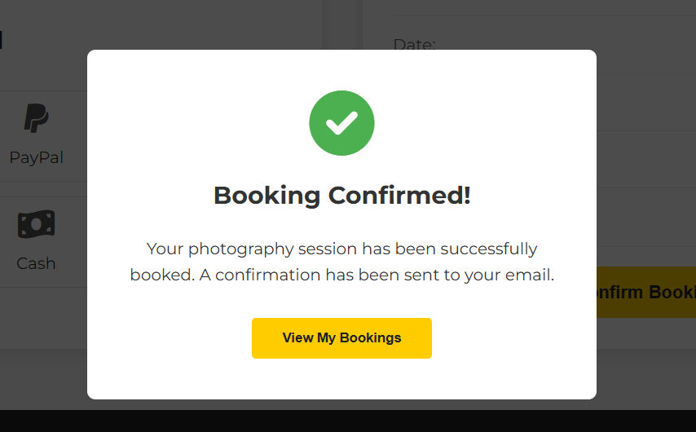

# Conclusion:

The **Capture Moments** application has been successfully developed and deployed using a modern, cloud-based architecture. By leveraging **AWS services** such as **S3 for secure image storage, Lambda for serverless processing, and DynamoDB for efficient data management**, the platform ensures a seamless and scalable experience for users to upload, store, and share their cherished memories. This system addresses the challenge of fragmented photo storage by providing a centralized, user-friendly solution with real-time accessibility.

The **cloud-native approach** allows the application to scale effortlessly as user demand grows, maintaining high performance without compromising speed or reliability. The integration of **React for the frontend and a serverless backend** ensures smooth interactions, from user authentication to photo uploads and album organization. Rigorous testing has validated all core functionalities, guaranteeing a robust and intuitive experience.

In conclusion, **Capture Moments** delivers a **modern, efficient, and secure** way to preserve and relive memories, enhancing user convenience while eliminating the hassle of managing photos across multiple devices. This project highlights the power of **cloud-based solutions** in solving real-world challenges, offering a reliable platform for personal and shared moments